LESSON 1

INTRODUCTION TO
COASTAL ENGINEERING
BACKGROUND INFORMATION
Contents
- What is engineering?
- The engineering design process
- The scientific method vs. the engineering design process
- Our engineering field site: North Beach, city of Racine

What Is Engineering?
Engineering is about creating solutions to the world’s challenges and designing the products that support our quality of life. Engineers have led or helped in the development of telephones (both rotary and cellular), bridges, computers, roadways, wastewater treatment plants, light bulbs, electric cars, theme parks, rocket ships, and more.
Engineers are creative problem solvers whose work impacts all aspects of society and includes the following specialties:
- Aerospace
- Agricultural
- Biomedical
- Civil and environmental
- Chemical and biological
- Computer and software
- Electrical
- Mechanical
- Nuclear

The focus of this unit is coastal engineering, a subspecialty of civil engineering. Coastal engineering is concerned with development along the coasts and the diverse structures that are built there. Coasts are highly valuable centers of residential (homes), recreation (beaches, boating), and economic (shipping, fishing) activity. For example, much of the stuff we own has been shipped across the ocean and transported along our coasts. These uses of the coast can be impacted by processes like waves, currents, and erosion. Coastal engineers design, construct, and carry out solutions to support human use of the coast in the face of these coastal processes. These solutions include structures to resist erosion, control flooding, build beaches, and create habitat for fish and wildlife.
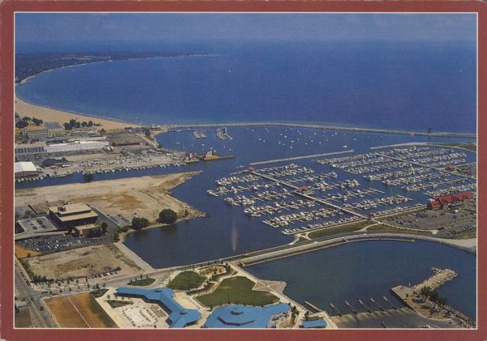Image source: Wisconsin Historical Society IM148591

B. The Engineering Design Process
The engineering design process is a series of steps that guides engineering teams as they solve problems. The design process is iterative, meaning that we repeat the steps as many times as needed, making improvements along the way as we learn from failure and uncover new design possibilities to arrive at great solutions.

The steps of the engineering design process are:
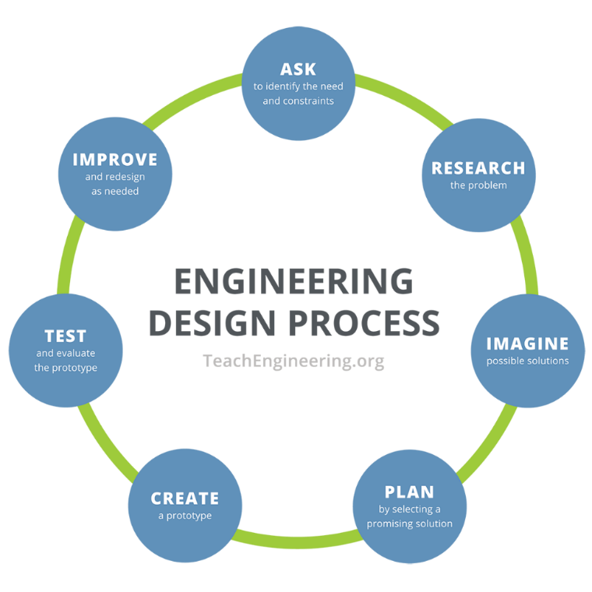Image source: Teach Engineering

Ask: to identify the needs and constraints;

Research the problem;

Imagine possible solutions;

Plan by selecting a promising solution;

Create a prototype;

Test and evaluate the prototype;

and improve and redesign as need

C. How is Engineering Different from Science?
“Scientists investigate what is; they discover new knowledge in the universe by peering into the unknown. Engineers design and create what has never existed before.”
- Joe Bordogna, Former Deputy Director, National Science Foundation.
The two disciplines have much in common, but one main difference is the scientific method is a linear process designed to investigate what is, while the engineering process is iterative and designed to solve an identified problem.
Scientists tend to focus on answering questions like: “What is it?” “How does it work?” and “How is it related to this other thing?” Engineers tend to focus on answering questions like: "How can I make it better?” and “What if I changed this?”

One way to visualize the different approaches within the two disciplines is illustrated here:
COMPARING SCIENTIFIC METHOD and
ENGINEERING DESIGN PROCESS

The Scientific Method | The Engineering Design Process
Is a linear process with a clear beginning and ending. | Is not linear. Does not have a structured beginning or end.
Must include only one independent variable. | May include multiple independent variables throughout the process.
Must include a formal hypothesis. | May include a hypothesis.
May include retesting. | Must include retesting.
Source: Dale & White (2020).

D. Our Engineering Field Site: North Beach, City of Racine

This unit includes field trips where we explore coastal engineering through a watershed experience. Our field experience will occur at North Beach along the Lake Michigan coast in Racine.
From Racine’s early beginnings as an official city in 1848, water has shaped its culture and its community. The Root River, which has a drainage area of 190 square miles, runs through downtown Racine as it flows into Lake Michigan through Racine Harbor. Lake Michigan provides the city with its municipal water supply.
A long history has influenced the coasts, with residents taxing themselves to have the Root River dredged into a harbor for the first time in 1843, leading Racine to be the fifth-busiest port on the Great Lakes by 1875. While little commerce takes place in the port today, Racine’s former industrial lakefront continues to impact life within this coastal community.
The industrial lakefront was transformed in 1987 with construction of a new breakwater, marina, and Festival Park, which have put a cultural and recreational focus on Racine’s identity as a Great Lakes coastal community.
The construction of Racine Harbor also illustrates how human activities have shaped the coast of Racine and its environmental conditions. The harbor acts to trap nearshore sediments that are pushed south along the coast by waves, helping form North Beach, a wide sandy beach to the north of the harbor.
Although the student stewardship project will focus on North Beach, it’s important to consider the coastal landscape around it. For example, the coast that is south of the harbor is cut off from sediment transport and lacks much beach, consisting instead of numerous rock breakwaters and revetments.
These two very different coastal landscapes dramatically depict the natural coastal processes of deposition and erosion as well as how coastal engineering can affect them. More recently, engineering has been used to work with nature through the implementation of green infrastructure along Racine’s coast to manage stormwater and improve water quality. Historic and modern engineering projects all along the coast of Lake Michigan illustrate the importance of water to Racine’s founding and history as well as the role human activities continue to have on shaping the city, and coast and water quality parameters seen today.

REFERENCES
Dale, T.C. and White, M.S. (2020) The Science Teacher’s Toolbox: Hundreds of Practical Ideas to Support Your Students. Jossey-Bass, Hoboken, N.J.
Teach Engineering: Ignite Stem Learning in K-12. (n.d.) Engineering Design Process. https://www.teachengineering.org/populartopics/designprocess
We Are Teachers: Sheffer, M. (2023, August 8) What Is the Engineering Design Process and How Can I Teach It? A Guide to Make Engineering Easy. https://www.weareteachers.com/engineering-design-process

