LESSON 1

INTRODUCTION TO COASTAL ENGINEERING

Lesson Overview
Objectives
After participating in this activity, students can:
Identify the steps of the engineering design process.
Explain the similarities and differences between science and engineering.
Perform tasks foundational to creating a map (e.g., estimate the distance between specified locations and determine the spatial orientation between two locations) by completing a distance and relative position chart.
Draw a map illustrating the relative positions of the school, Lake Michigan, and a feature of the student’s choice.
Iteratively use the engineering design process to create a sequence of clay objects with the goal of designing an object that floats.

Middle school students are introduced to the field of coastal engineering and start to become familiar with the engineering design process, a key method coastal engineers use to address problems at our shorelines. Current coastal engineering issues include erosion, loss of habitat, flooding, property damage, threats to human life and wellbeing, and more. The students are also oriented to the location of the field site on the shore of Lake Michigan at North Beach. The geographic positions of the school, Lake Michigan, and Racine Harbor serve as reference points as students build, or enhance, their personal conceptual geographic map of natural and construced features within the city of Racine.

Lesson Concepts
- Science and engineering are related in that they incorporate similar steps. However, the scientific method is a linear process designed to investigate what is, while the engineering design process is iterative and designed to solve an identified problem.
- Maps serve as two-dimensional representations of features on a landscape.
- A map’s key and scale are important to interpreting how a map represents actual features found on a landscape.

Background Information for Educators
Subject Areas
Environmental Literacy & Sustainability | Geography | Mathematics | Science & Engineering

Lesson 1: Introduction to Coastal Engineering - Background

Prior Knowledge
Students should have a basic understanding
- of the property of liquids, for example that they flow and that their movement can exert force onto solid objects.
Lesson Summary
- Guided practice: What is engineering?
- Independent practice: Using the engineering design process to improve a design
- Guided practice: Introducing our coastal engineering field site
- Independent practice: Locating our coastal engineering field site
- Assessment
- of the concepts of surface area and buoyancy and the correlation between these concepts.
- that maps serve as a two-dimensional representation of space.
- that a map’s key and scale are important to interpreting how a map represents actual features on the landscape.

Possible Misconceptions
- Scientists work in labs, while engineers work in the field.
- Distance as measured on a map always converts to actual distance on the landscape using the same conversion factor (i.e., not understanding that scale can, and does, change from one map to another).
1

Next Generation Science Standards
Great Lakes Literacy Principles
Principle 6
The Great Lakes and humans in their watersheds are inextricably interconnected.
6C: The Great Lakes are affected directly by the decisions and actions of people throughout its watershed which includes parts of the states of Illinois, Indiana, Michigan, Minnesota, Ohio, Pennsylvania, New York, and Wisconsin, the Canadian provinces of Ontario and Quebec, and tribal lands.
Principle 8
The Great Lakes are socially, economically and environmentally significant to the region, the nation and the planet.
8B. The waters of the Great Lakes have been significant to historical settlement and development. The lakes’ names and the names of many cities, counties and landmarks along their shores have Native American or immigrant origins. This freshwater resource will continue to play a role in future habitation of the area.

MS-ETS1-1 Engineering Design
Define the criteria and constraints of a design problem with sufficient precision to ensure a successful solution, taking into account relevant scientific principles and potential impacts on people and the natural environment that may limit possible solutions.

MS-ETS1-2 Engineering Design
Evaluate competing design solutions using a systematic process to determine how well they meet the criteria and constraints of the problem.

MS-ETS1-3 Engineering Design
Analyze data from tests to determine similarities and differences among several design solutions to identify the best characteristics of each that can be combined into a new solution to better meet the criteria for success.

MS-ETS1-4 Engineering Design
Develop a model to generate data for iterative testing and modification of a proposed object, tool, or process such that an optimal design can be achieved.

NGSS Cross-Cutting Concepts

3. Scale, proportion and quantity. In considering phenomena, it is critical to recognize what is relevant at different measures of size, time and energy and to recognize how change in scale, proportion or quantity affect a system’s structure or performance.

6. Structure and function. The way in which an object or living thing is shaped and its substructure determine many of its properties and functions.

Wisconsin Model Academic Core Ideas

ESS2.C: The Role of Water in Earth's Surface Processes

ESS3.B: Natural Hazards
ESS3.C: Human Impacts on Earth Systems

Wisconsin Model Academic Standards
ELS.C1.B.m Sense of Place Identify the relationship between parts of natural and cultural systems in connecting communities into regional systems (e.g., watershed areas, political jurisdictions, ethnic communities). Understand the relationships between the environment and geography of a locality and its history, culture, and economy.
ELS.EX5.C.m Examine Cultural System Emphasis Examine how historical and contemporary factors shape a sustainability issue. Evaluate how historical and contemporary natural resource use, practices, and distribution has [sic] affected human geography and analyze the impact on natural systems.
SS.Geog 1.a.m Tools of Geography Use paper and digital maps to ask and answer geographic questions.
SS.Geog 1.c.m Mental Mapping and Maps from Memory Construct a mental map of regions.
M.7.G.A.1 Draw, construct, and describe geometrical figures and describe the relationships between them Solve problems involving scale drawings of geometric figures, including computing actual lengths and areas from a scale drawing and reproducing a scale drawing at a different scale.
SCI.ETS3.B.m Science and Engineering are Unique Ways of Thinking with Different Purposes Science asks questions to understand the natural world and assumes that objects and events in natural systems occur in consistent patterns that are understandable through measurement and observation. Science carefully considers and evaluates anomalies in data and evidence. Engineering seeks solutions to human problems, including issues that arise due to human interaction with the environment. It uses some of the same practices as science and often applies scientific principles to solutions.
SCI.ETS3.C.m Science and Engineering Use Multiple Approaches to Create New Knowledge and Solve Problems Engineers develop solutions using multiple approaches and evaluate their solutions against criteria such as cost, safety, time, and performance. This evaluation often involves trade-offs between constraints to find the optimal solution.
SCI.SEP1.A.m Asking Questions Ask questions to clarify or refine a model, an explanation, or an engineering problem.
SCI.SEP4.m Defining a Problem Analyze data to define an optimal operational range for a proposed object, tool, process, or system that best meets criteria for success.
SCI.SEP6.B.m Designing Solutions Apply scientific ideas or principles to design, construct, and test a design of an object, tool, process, or system. Undertake a design project, engaging in the design cycle, to construct and implement a solution that meets specific design criteria and constraints. Optimize performance of a design by prioritizing criteria, making trade-offs, testing, revising, and retesting.
SCI.ETS1.B.m Developing Possible Solutions A solution needs to be tested and then modified on the basis of the test results in order to improve it. There are systematic processes for evaluating solutions with respect to how well they meet the criteria and constraints of a problem.
SCI.ETS1.C.m Optimizing the Design Solution Although one design may not perform the best across all tests, identifying the characteristics of the design that performed the best in each test can provide useful information for the redesign process. The iterative process of testing the most promising solutions and modifying what is proposed on the basis of the test results leads to greater refinement and ultimately to an optimal solution.
MS-ETS1-2 Engineering Design Evaluate competing design solutions using a systematic process to determine how well they meet the criteria and constraints of the problem.

Key Vocabulary
Constructed As an adjective refers to any sort of material forming or earth-moving to make something. For example, constructed dune and constructed wetland are common terms. The word can also be a verb.
Engineering Is a systematic and often iterative approach to designing objects, processes, and systems to meet human needs and wants.
Human-made Pertains to things that result from human actions but are not actually fully formed by humans. For example, "human-made lake" is a term people use rather than "constructed lake" since you don't usually construct the lake, you construct a dam and then the lake is formed behind it.
Iterative Refers to repetition of the steps as many times as needed, ideally making improvements each time.
Optimize Is to improve a solution based on the results of simple tests including failure to meet predetermined criteria.
Technology Is any modification of the natural world made to fulfill human needs or desires.

Additional Resources for Educator

About Engineering Careers
Teach Engineering Types of Engineering for Kids’ Exploration

About the Root River Watershed

Wisconsin Dept. of Natural Resources: Root-Pike Watershed

Root-Pike Watershed Initiative Network

About early Racine Harbor engineered infrastructure

Racine Harbor (Root River) Lighthouse

Classroom Supplies/Resources Needed

Files Needed
- Educator Background Information Lesson 1: Introduction to Coastal Engineering -Background
- Video What Is Engineering?
- Slideshow The Engineering Design Process
- Student Handout The Engineering Design Process For a Floatable Object
- Slideshow Racine Harbor Through Time
- Student Handout My Map of the City of Racine
- Slideshow Return to Racine Harbor
- Assessment Science vs. Engineering: Similarities and Differences
- Assessment Science vs. Engineering: Similarities and Differences-Answer Key
- Assessment Lesson 1 Exit Slip
- Assessment Lesson 1 Exit Slip–Answer Key
- Educator Feedback Form

Technology needed
- 1:1 device for students, with internet connection
- Laptop, projector and screen or interactive whiteboard for teacher to share PowerPoint presentations

Supplies for floatable object activity
- Clay (¼ lb. per group of 3 to 4 students)
- Towels for cleanup
- Clear plastic storage container
- Washers (15 per group)
- Bucket to dump wastewater (1 per class)

LESSON STEPS

1. Guided Practice: What Is Engineering?
15 minutes
Begin by asking students what an ideal utensil looks like for eating apple pie à la mode—or pie with ice cream on top. If we eat with a standard spoon or fork, many of us leave a bit of pie or ice cream behind on the plate. How can we maximize our serving, not losing any of the tasty morsels? Engineers and their engineering design process might help us create a solution to this problem.

1a What Is Engineering?
Video What Is Engineering?
(Length 3:43 minutes)
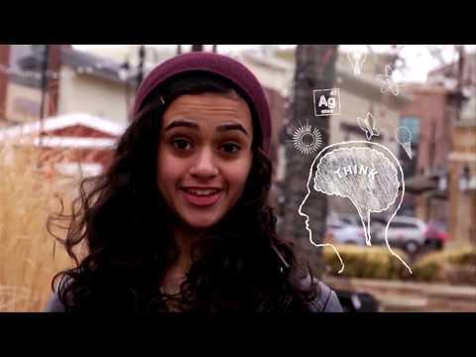

TRANSITION
The video highlights the different types of things engineers do. What do each of these types of engineering have in common? All engineers use the same underlying process to do their work – the engineering design process.

1b The Engineering Design Process
Engineers use the engineering design process (EDP) to identify and solve problems. The EDP is a series of steps that guide engineering teams. The design process is iterative, meaning that the engineer repeats the steps as many times as needed, making improvements along the way. Using the EDP helps engineers to learn from failure and uncover new design possibilities. The EDP is similar to but not the same as the scientific method.
Let’s consider the EDP to maximize our serving of apple pie à la mode.
Slideshow The Engineering Design Process
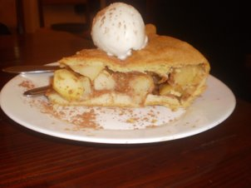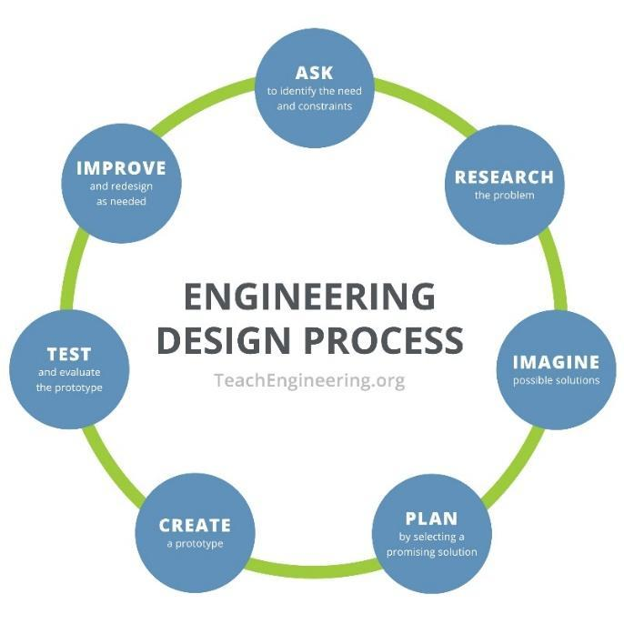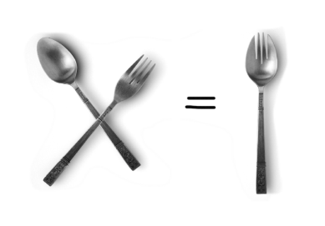

The Seven Steps of the Engineering Design Process
- Ask: Identify the Need (Criteria) & Constraints We want to eat delicious pie à la mode, but it tends to be messy, and we often lose some of the melted ice cream when using a fork. It’s also difficult to get bite-sized pieces when using a spoon. We are constrained by how large our utensils should be by the size of the human mouth—perhaps you have seen “baby spoons.”
- Research Since we are designing a new utensil, it is imperative that we research how pies are eaten. Books or a web search might tell us, but we can also experiment with various items that we think might work: a fork, a spoon, a shovel.
- Imagine: Develop Possible Solutions Using a fork or a spoon, or a shovel, for eating pie à la mode, is not perfect. There must be a better way. I wonder what happens when we combine two tools? Maybe we could develop a “spork” or a “foon”?
- Plan: Select a Promising Solution Since we plan to market our new utensil, “spork” sounds better – let's try that.
- Create: Build a Prototype
- Test and Evaluate Prototype Eat pie à la mode!
- Improve: Redesign as Needed It works just great, and the pie and ice cream are delicious! A spork is born.

2. Independent Practice: Using the EDP to Improve a Design
15 minutes
The EDP unites all types of engineering, from nuclear to computer to environmental to electrical. Each type of engineering uses the EDP to find creative solutions to society’s problems. This unit on engineering is focused on coastal engineering, a subspecialty of civil engineering, and includes a field experience at North Beach, in the city of Racine. At North Beach, engineering has transformed the coastline to combat flooding, erosion, poor water quality, beach closures and more. To understand what has changed at North Beach, it’s important to understand the changes that have occurred at a location just south of North Beach—at Racine Harbor, a place where boats, buoys, piers and other floatable objects have long been important.
To practice the EDP, students are asked to use clay to create an object that floats. Students use a small quantity of modeling clay (and if they think of it, anything else they might have at hand) to test the object in water, using washers as the load to measure the capacity to float. They should work in teams of 3 or 4 and incorporate all the steps in the design process. They should complete the EDP and the construction in about 10 minutes.
Student Handout The Engineering Design Process for a Floatable Object

Questions to consider
- What designs seemed to work best? What is it about these designs that made them successful?
- What designs did not seem to work well? What is it about these designs that made them less successful or unsuccessful?
- Did your design change throughout the activity? How?
- Describe how you used the EDP as you solved these design challenges.
Adapted from Teach Engineering, Clay Boats

TRANSITION
Because coastal engineering is firmly connected to a specific place, the students will be introduced to their place using a variety of mapping and other placed-based tools over the course of the unit.

3. Guided Practice: Introducing our Engineering Field Site
10 minutes
Instructor: We’ve just designed an object to float. There is a place within the city of Racine called Racine Harbor where floating objects, specifically boats, have long been important.
Instructor asks the students if they ever visited the harbor? If so, what did you see? If not, what do you imagine you might see at a harbor? Create a list of features and highlight natural, human-made, and constructed features.
Slideshow Racine Harbor Through Time
Instructor plays the slideshow of historical and modern images of Racine Harbor and asks the students to observe the images and identify other features of the harbor not included on their original list. Create an updated list and categorize the new list by highlighting the constructed safety features (e.g., coast guard station, lighthouse, docks) that aid the transportation industry as well as constructed features (jetties and seawalls) that control erosion. Indicate that we’ll be talking about constructed structures in more detail later in the unit.

TRANSITION
The Racine Harbor is just one location that is important within the city of Racine. The next activity will give the students the opportunity to share what they already know about some of the features of the city.
To begin their orientation to their engineering field site, North Beach, along the Lake Michigan shoreline, the students will start by making a map of various points in Racine with the end goals of understanding 1) their own personal connection to the watershed and 2) the importance of natural features, such as the Root River and Lake Michigan, which resulted in the city of Racine being established where it is.

4. Independent Practice: Locating our Engineering Field Site
15 minutes
4a. My Map of the City of Racine - Ask students to indicate their estimate of distances between various points (complete a chart) and then draw a map (on paper) of the elements they’ll look at later (Lesson 3) on Google Earth. (Ideally save the student drawings so that they can serve as a "pre-assessment" of student mapping skill development.)
Student Handout My Map of the City of Racine
4b. Enabling Students to Check Their Responses - After the students complete the mapping activity, show the “Return to Racine Harbor” slideshow.
Slideshow Return to Racine Harbor

5. Assessment
- For objectives 1 and 2, students complete the Science vs. Engineering: Similarities and Differences activity (Answer Key) OR the lesson one Exit Slip (Answer Key)
- For objectives 3 and 4, students complete the My Map of the City of Racine
- For objective 5, students complete The Engineering Design Process for a Floatable Object

LESSON EXTENSIONS
Resources for these activities are included within the “Additional Resources for Educator” section (page 4).
- Students investigate the similarities and differences between the engineering career fields.
- Students investigate the Root River Watershed. What are its boundaries? What other watersheds are adjacent?

EDUCATOR FEEDBACK FORM
- Educator Feedback Form

REFERENCES

EDUCATION
Center for Great Lakes Literacy. (2013). Great Lakes Literacy Principles.
Clay Boats from Teach Engineering, accessed July 13, 2021.
Dale, T.C. and White, M.S. (2020) The Science Teacher's Toolbox: Hundreds of Practical Ideas to Support Your Student. Jossey-Bass, Hoboken, N.J.
The Engineering Design Process from Teach Engineering, accessed July 13, 2021.
National Research Council. (2012). A Framework for K-12 Science Education: Practices, Crosscutting Concepts, and Core Ideas. Committee on a Conceptual Framework for New K-12 Science Standards. Board on Science Education, Division of Behavioral and Social Sciences and Education. Washington, DC: The National Academies Press. Full text.
Next Generation Science Standards (NGSS) Lead States. 2013. Next Generation Science Standards: For States, By States. MS-ESS3-3 Earth and Human Activity. Washington, DC: The National Academies Press.
Next Generation Science Standards (NGSS) Lead States. 2013. Next Generation Science Standards: For States, By States. Cross Cutting Concepts. Washington, DC: The National Academies Press.
Learn more: References for Dimension 3 – Earth and Space Sciences.
Wisconsin Department of Public Instruction. (2018). Wisconsin Standards for Social Studies.
ESS2.C: The Role of Water in Earth's Surface Processes. Full text.
ESS3.B: Natural Hazards. Full text.
ESS3.C: Human Impacts on Earth Systems. Full text.

COASTAL ENGINEERING
Learn more: References for Dimension 3 – Earth and Space Sciences
Teach Engineering: Ignite Stem Learning in K-12. (n.d.) Clay Boats from Teach Engineering, accessed July 13, 2021.
Teach Engineering: Ignite Stem Learning in K-12. (n.d.) The Engineering Design Process, accessed July 13, 2021.
Teach Engineering YouTube (2019). What Is Engineering? https://www.youtube.com/watch?v=H9VDkvgGmVo

