LESSON 2

COASTAL FEATURES & PROCESSES OF THE GREAT LAKES
BACKGROUND INFORMATION
Contents
- Coastal features of Lake Michigan near Racine
- What coastal processes shape the Great Lakes?
  - Water levels and the water cycle
  - Waves
  - Currents
  - Sediment transport
- How do these four processes interact to shape the coasts?
- Our engineering field site: North Beach, city of Racine
- Comparing Racine and Algoma

Coastal Features of Lake Michigan Near Racine
The coast is the area where the lake and the land interact. This is where we can see evidence of the lake shaping the land through a variety of coastal processes. These coastal processes create landscapes with differing profiles. Some landscapes are steep, others are flat.
This is a typical bluff profile seen in the Racine area.
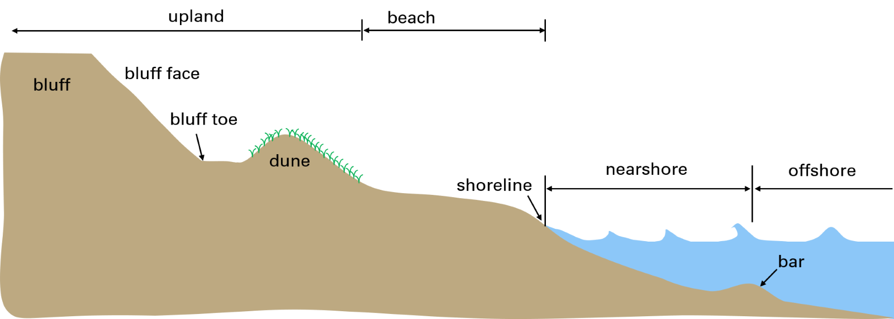Image source: Adam Bechle, Wisconsin Sea Grant
The land and water interface, or coastal profile, is composed of several components. The following are eight typical land components.
- Bar Underwater ridge of sand running roughly parallel to the shore.
- Shoreline The point where the lake water meets the land.
- Beach The zone of loose sediment between the shoreline and a line of permanent vegetation or a change in sediment. The beach typically ends where the dune or bluff begins.
- Upland The zone of land above the reach of waves and landward of the beach. The upland typically includes the dunes and/or bluffs.
- Dune The ridge of loose, wind-blown sand. This is often the first location that has permanent vegetation.
- Bluff A soil slope rising above the beach.
- Bluff face The sloping section of a dune, bank, bluff, or coastal structure.
- Bluff toe The base of a dune, bank, bluff, or coastal structure.
The water components of the coastal profile are divided into two areas:
- Nearshore The zone of water between where waves begin breaking and the shoreline.
- Offshore The zone of water lakeward of where wave breaking occurs. The offshore area is typically on the lakeward side of a bar.

B. What Coastal Processes Shape the Great Lakes?
Four processes shape the Great Lakes coast. Each of these processes has a series of factors, components, and variables that determines how the coast is shaped at a particular location.
- Lake levels and the water cycle
- Waves
- Currents
- Sediment transport

Process 1 – Changing Lake Levels Due to the Water Cycle
In the Great Lakes, water levels naturally fluctuate over several feet from year to year and over decades, primarily driven by climatic influences like precipitation, runoff, and evaporation. Water levels also vary seasonally, with a low in winter and a peak in summer.
Hydrologic (Water) Cycle
Components of the water budget include:
- Precipitation water in the form of rain, snow, sleet, or hail. For the lake’s water budget, we only count precipitation that falls directly onto the lake.
- Percolation the process of precipitation seeping into the ground.
- Runoff water that drains off the land in a lake’s watershed to the lake. It is impacted by precipitation over land, percolation into the ground, evaporation over land and transpiration (water sucked up by plants).
- Transpiration water that is sucked up by plants and ultimately returned to the air as water vapor.
- Evaporation water released to the atmosphere from the lake surface. The greatest amount of evaporation will occur when the following three conditions are met:
  - Warm water temperatures and cold air temperatures (warmer water can evaporate quicker)
  - Low relative humidity (so the air can soak up water)
  - High wind speeds (so new dry air replaces air that soaked up water)
- Outflow a removal of water to a particular portion of the hydrologic system of the watershed, for example, water flowing out to a downstream lake.
- Inflow an addition of water to a particular portion of the hydrologic system of the watershed, for example, water flowing in from an upstream lake.
- Groundwater table the boundary (not a straight line) between the saturated zone (where water fills the space between soil particles) and the unsaturated zone (where air fills the space between soil particles).
The hydrologic cycle (water cycle) is the continuous, closed-loop circulation of water between the Earth’s surface, atmosphere, and subsurface. Driven by solar energy and gravity, the hydrologic cycle (see graphic on the next page) involves water moving from one location to another and also changing physical states—liquid, gas, solid—as it evaporates from oceans/land, condenses into clouds, and precipitates back to Earth.

Water Budget
For each watershed, or geographic location through which water moves, lake level is determined by the water budget, which accounts for how much water goes into and out of the lake. If more water enters the lake than leaves, lake levels rise. If more water leaves the lake than enters, lake levels go down.
Thus, the water budget is the net result of how the water cycles within a particular geographic location within a specified period of time.
Again, lake water levels, as well as the height of the groundwater table, are determined by the water budget.

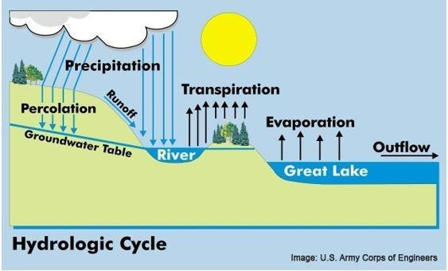
Hydrologic Cycle (Reprised)
The amount of water on Earth remains constant. Approximately 2.5% to 3% of Earth's water is freshwater, with the remaining 97% or more residing in oceans as saltwater. Of this small percentage of freshwater, only about 0.5% to 1% is easily accessible to humans, as the vast majority is locked in ice caps, glaciers, or deep underground.
The city of Racine is just one of many communities along the more than 1,600 miles (including islands) of Lake Michigan shoreline. These coastal communities are subject to changing Lake Michigan water levels as precipitation, precolation, runoff, transipiration, and evaporation vary over time.
Image source: U.S. Army Corps of Engineers
https://www.watershedcouncil.org/influences-on-great-lakes-water-levels.html

Year-to-Year Variations
The water levels of the Great Lakes change over periods of consecutive years due to climatic variability that influences the water budget. Generally, continuous wet and cold weather causes lake levels to rise due to increased precipitation and decreased evaporation, while continuous warm and dry weather causes lake levels to decline. In Lake Michigan, the highest water level ever recorded was in October 1986 (582.35 feet). The lowest water level ever recorded was in January 2013 (576.02 feet). That is a 6.33-foot range of water levels from high to low.
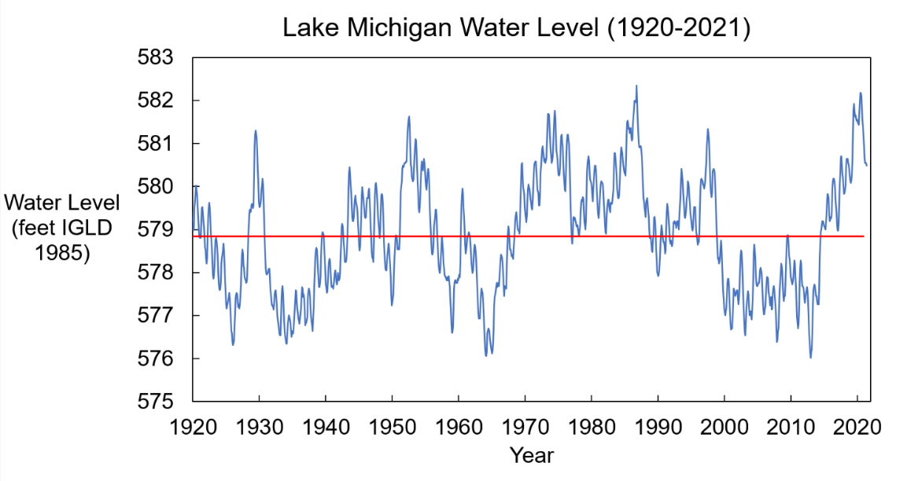
Image source: Adam Bechle, Wisconsin Sea Grant
IGLD 1985 = International Great Lakes Datum, 1985

Seasonal Variations
The water levels of the Great Lakes respond to seasonal changes in climate. In Lake Michigan, summer water levels are about a foot higher than winter water levels (on average).
- Spring Lake levels typically rise as runoff from melting snow and ice on land and increasing precipitation reach the lake.
- Summer Lake levels peak as precipitation continues to increase and evaporation is low because the air is typically humid.
- Fall Lake levels decline as precipitation starts to decrease and evaporation increases as cold, dry air blows across the warmer water of the lakes.
- Winter Lake levels reach a low as precipitation decreases and potential runoff stays on the land in the form of snow and ice. Evaporation is at a maximum as cold, dry air blows across the warmer water of the lakes.
This diagram of factors impacting Great Lakes water levels illustrates seasonal variations.
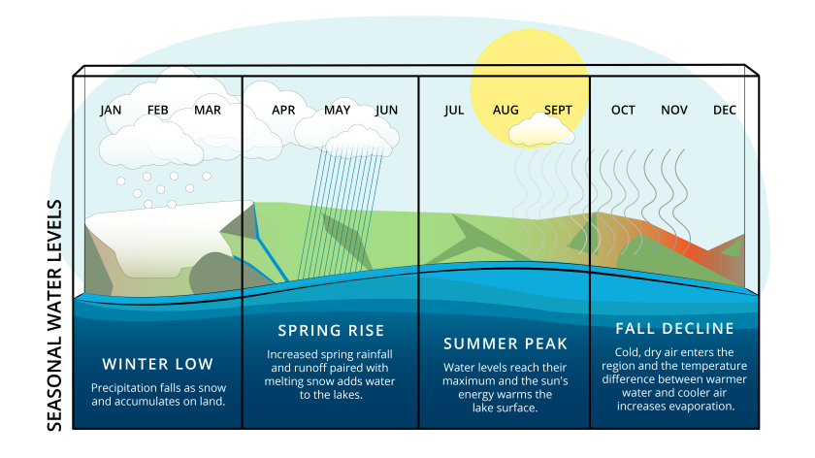
Image source: NOAA, https://greatlakesseagrant.com/projects/water-levels/

Process 2 - Waves
Waves are created by wind blowing over the water surface. Energy is transferred from the wind to the water surface in the form of waves.

Higher waves have more wave energy. Wave height is determined by the wind speed, the fetch distance (which is the length of water surface exposed to the wind) and the duration that the wind is blowing from roughly the same direction over water.
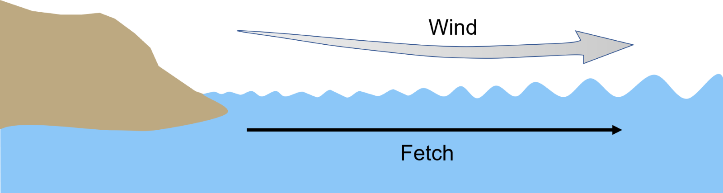
Image source: adapted from Tammy Pelletier, Washington State Dept. of Ecology https://www.vos.noaa.gov/MWL/apr_06/waves.shtml
As waves approach the shore, they begin to “feel” the lake bottom and release energy through breaking before striking the shore. This is because in shallower water, especially near a bar, the waves experience friction with the lake bottom (if the water is deep enough, waves don’t experience friction). The lower part of the wave slows down due to friction, while the top of the wave keeps moving. This causes the wave to break, or overturn. This process is similar to a human tripping – when your foot unexpectedly slows down either due to friction or hitting something, your upper body keeps moving and tumbles over.
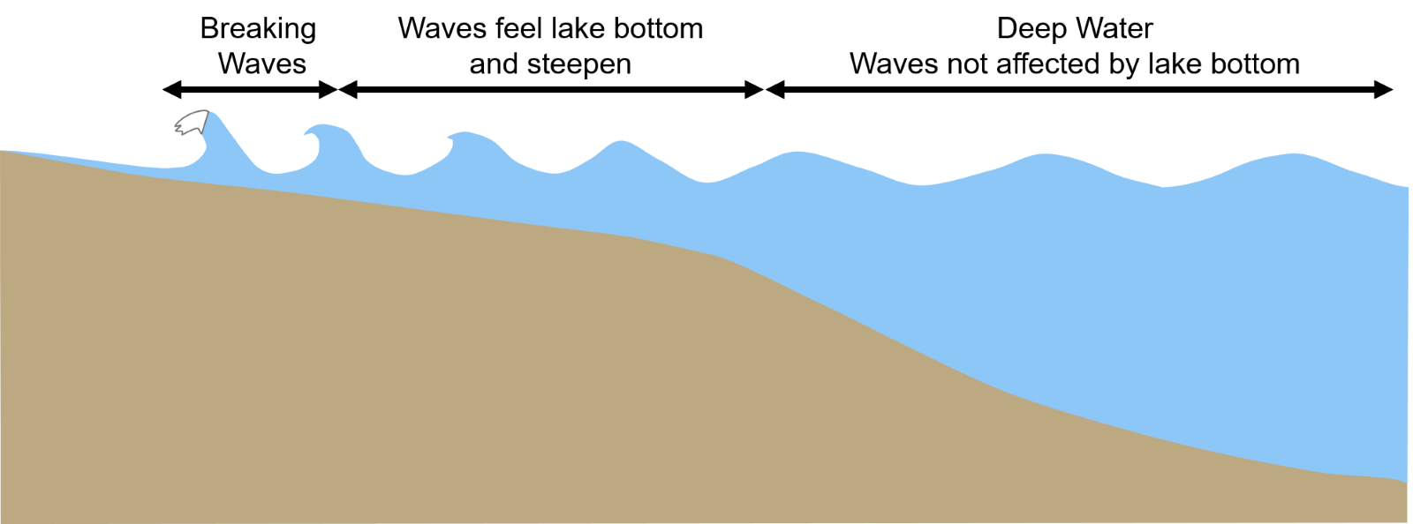
Image source: Adapted from U.S. Army Corps of Engineers Coastal Engineering Manual
In the Great Lakes, the largest waves come in the late fall and winter, when storms with high sustained winds are most common. Summer thunderstorms can bring high winds but those are typically shorter duration compared with winter storm winds. This means that waves in the summer do not grow as large as they do during the winter.
Wind can also push water to one side of the lake, temporarily raising the water levels in a process known as storm surge. While water levels rise on one side of the lake, they fall on the other side. When the wind stops, water can slosh back and forth from side to side in the lake in a process known as a seiche. Seiche are usually caused by high winds and atmospheric pressure changes. Storm surges and seiches are considered waves that change water levels over a period of hours.
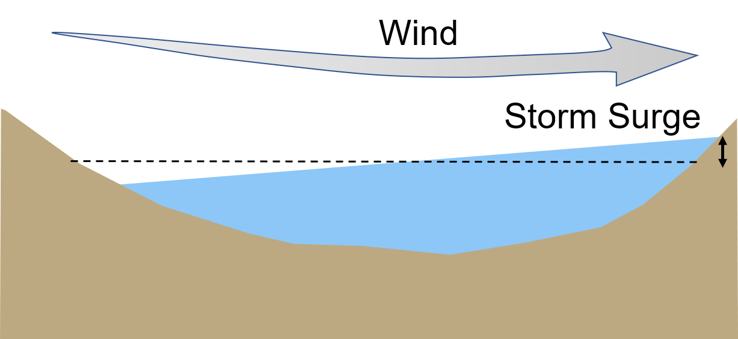
Image source: Adam Bechle, Wisconsin Sea Grant
A (0.16) time lapse video of a Great Lakes seiche occurring in a coastal wetland on March 28, 2025 is available via the Wisconsin Sea Grant YouTube channel.

Process 3 - Currents
When waves hit the shore, they push water with them. This flow of water is known as a current.

Alongshore (longshore) currents
When waves approach the coast at an angle, they push water along the coast parallel to the shore. These are known as alongshore currents. Alongshore currents are also called longshore currents.
Typically, the strength of the alongshore current increases as the distance from the beach increases. The current strength then decreases as the distance from the beach and the depth of the water increases. This current strength pattern is represented by the elongated bell-shaped curve illustrated in the longshore current diagram. The direction of the alongshore current will most likely be in the same direction that the waves are traveling.
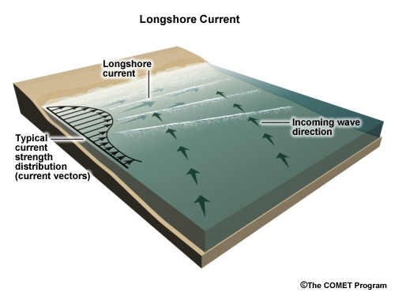
Image source: The COMET Program

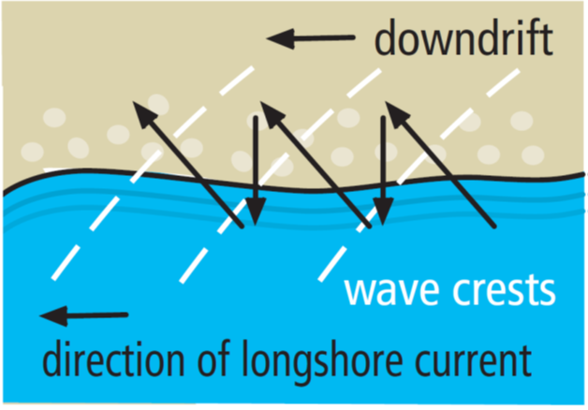
This second illustration of the direction of the longshore current also illustrates the direction of sand movement caused by the current. The zig-zag black arrows show the direction of sand movement caused by longshore currents. This movement of sand is explained in more detail in the following “Process 4 - Sediment transport section” and is known as downdrift.
Within the graphic, randomly spaced tan circles represent individual grains of sand or sediment. (This is a very magnified view.)
A series of three wave crests, represented by parallel, curved white lines, intersect the shoreline at approximately a 30 degree angle. These wave crests approach the shore moving from right to left, creating a longshore current in the same direction.
Due to the longshore current, wave crests, and gravity individual sand grains will move across the beach. In this case, the sand grain will move onto the beach at approximately a 30 degree angle--the same as the wave crest.
Then, due to gravity, the sand grain will roll back down the beach toward the lake. This repeats with each wave crest, moving the sand grain along the shore.
Image source: Wisconsin Sea Grant
The resulting movement of sand is represented in the image by a series of arrowed lines that ultimately form a zig-zag pattern; with the "zig" arrows moving from the lake onto the beach at approximately 30 degree angles and the "zag" arrows moving from the beach to the lake at approximately 90 degree angles.

Rip currents
Rip currents are powerful, narrow channels of fast-moving water.
Rip currents can form when waves break over a sandbar, which causes water to build up between the shore and the sandbar. This built-up water finds a pathway back to the open lake, typically through a low spot in the sandbar. This narrow pathway of water can flow at a high rate, creating a rip current. Rip currents can also form when alongshore currents run into a structure that sticks out into the water like a pier. When the alongshore current hits the structure, it is redirected along the structure and out into the lake.
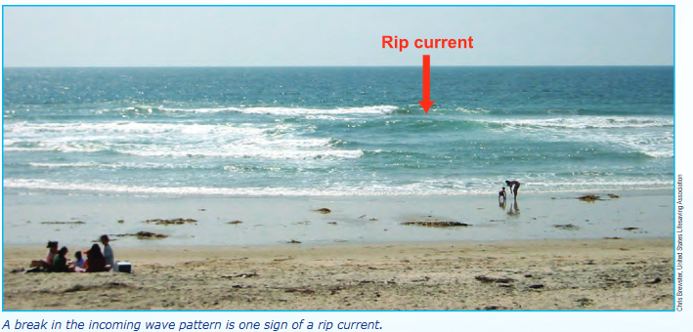
Image source: Chris Brewster, US Lifesaving Association
Rip currents flow much faster than people can swim and can carry swimmers away from the shore and out into the lake.
Directions of what to do if caught in a rip current are:
1. Don't fight the current.
2. Swim out of the current, then to shore.
3. If you can't escape, float or tread water.
- If you need help, call or wave for assistance
The illustration on the next page uses a series of arrows arranged in the formation of backward facing and forward facing letter "Cs" — with the rip current occupying the space between the "backs" of the letter Cs. The "escape" routes can be found at the center of the letter Cs extending outward and also at the top of the letter Cs. In other words, escape routes from the rip current are found by swimming parallel to the shore to get out of the rip current, not back towards the shore against the rip current.
A silhouette of a swimmer is located in the space between the top of the two Cs — at the upper edge of the rip current and starting toward the escape route.
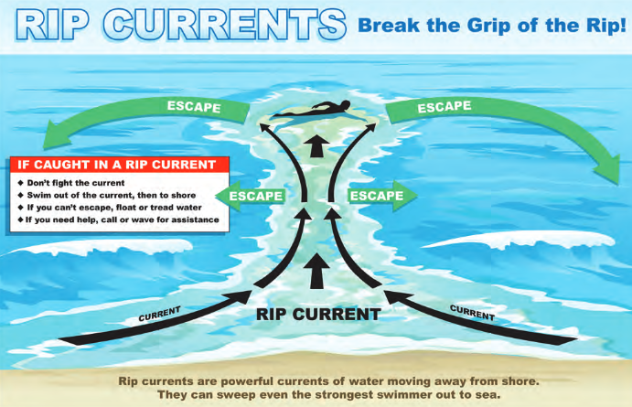
Image source: Dave Brenner, Michigan Sea Grant

Process 4 - Sediment transport
Waves and currents, two types of moving water, construct and maintain beaches by picking up and transporting sediments like sand and gravel. The faster the water moves, the bigger the sediment particles the water can transport. When the water movement slows down or stops, the sediments fall – or deposit – back down to the bottom. If the sediment that is picked up and carried away is not replaced by sediment transported and deposited from somewhere else, then erosion occurs.
Sediment is moved both perpendicular to the shore (cross-shore transport) and parallel to or along the shore (alongshore transport). Sediment transport builds and maintains beaches. When sediment transport becomes interrupted, it can lead to the loss of beaches.

Cross-shore sediment transport
Large storm waves move sediment from beaches and to nearshore bars. In the Great Lakes, erosive storm waves typically occur in the fall and winter. Gentler, smaller waves in the summer can redeposit sediment (e.g., sand) onto the beach.
Water levels can greatly affect cross-shore sediment transport. At high water levels, waves can more easily erode the beach. At low water levels, sediment stored in offshore bars is more readily suspended in the shallower water depths and can be transported back to the beach.
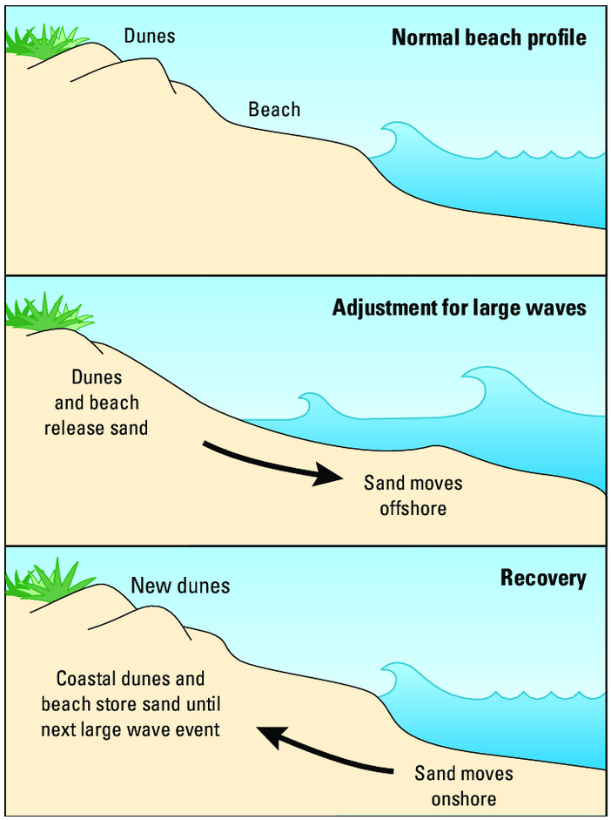
Seasonal beach-profile adjustments induced by seasonal swell variations and resulting cross-shore sediment transport.
Panel 1: Normal beach profile
Dunes, beach, and gently sloping lake bed in the nearshore area. Waves are of normal height and break near the shoreline.
Panel 2: Adjustment for large waves
Dunes and beach release sand causing the height and slope of the beach to decrease as sand moves offshore. A bar typically forms at some distance from the shoreline.
Panel 3: Recovery
Coastal dunes and beach store sand as sand moves onshore until the next large wave event. The height and number of dunes and slope of the beach increases.
Image source: University of Hawai’i Coastal Geology Group

Alongshore Sediment Transport
Sediment is also moved parallel to the shore by waves and currents. When waves approach the coast at an angle, they push water along the coast. These alongshore currents carry sediment with them along the shore, a process known as alongshore sediment transport.
When more sediment moves out of an area (in the “downdrift” direction) than moves into an area (from the “updrift” direction), erosion occurs to balance this deficit.

If structures are built out into the water, they can affect sediment transport. As waves and currents hit the structures, the water flow tends to slow down. This can cause sediment to be deposited.

Aeolian sediment transport
Winds can pick up and move beach sediments. Winds blowing towards the shore will transport sediment away from the lake and form dunes on the shore.

C. How Do These Processes Interact to Shape the Coast?
Waves are the dominant force shaping the coast. While high water levels can submerge large portions of the beach, wave action is the process that actually erodes beach and bluff sediments. Water levels do affect where the waves do their work. High water levels allow waves to reach further up the beach to more easily cause erosion to the beach, dunes, and bluff. High water levels also allow waves to more easily reach and damage structures along the coast. When water levels are low, waves work to erode the bed of the lake.

Waves drive the currents and sediment transport in the nearshore. The direction of currents and sediment transport is determined by the direction of the waves. The magnitude of the currents and sediment transport is determined by the size and direction of the waves (i.e., if waves strike the beach head on, the alongshore currents and transport will be lower than waves striking at an angle).
D. Our Engineering Field Site:
North Beach, City of Racine

Fetch
First, we need to consider how waves commonly approach the Racine area. The largest waves are likely to come from the direction with the longest fetch. For Racine, this is the northeast direction. Waves also approach Racine from other directions, but the northeast is the direction from which waves are likely to be the largest. With a dominant wave direction from the northeast, currents and sediment transport are most commonly heading along the shore in the direction from north to south.
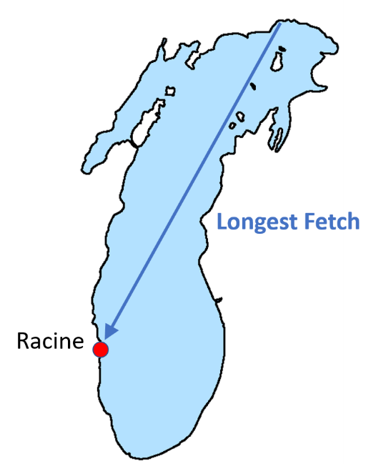
Image source: Adam Bechle, Wisconsin Sea Grant

Beach Width
The results of these dominant wave, current, and sediment transport directions can be seen when we look at an aerial photo of Racine Harbor. North Beach is formed by sediment transported from north to south and deposited when the currents hit Racine Harbor. Notice how much larger and wider the beach is north of the harbor than it is south of the harbor. What happens to sediments south of Racine Harbor? They get transported south by the dominant waves and currents instead of piling up near the harbor.
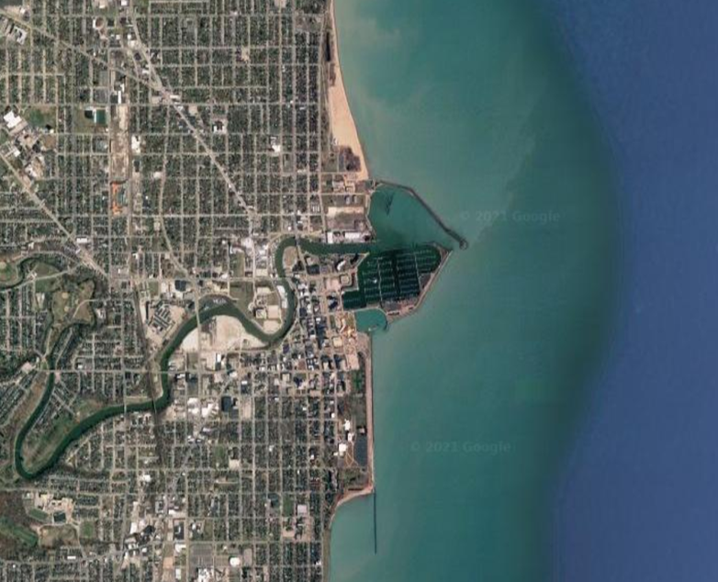
Maps Data: Google, ©2021 Landsat/Copernicus, Maxar Technologies, U.S. Geological Survey, USDA Farm Service Agency, Map data ©2021

Impact of Water Levels
How do water levels affect North Beach? Let’s compare what North Beach looked like in 2010, when water levels were below average, to 2020, when water levels were near record highs.
The southern end of the images, where the north breakwater enters the lake and the parking lot that lies to the north of Barker Street and west of Hoeffert Street serve as reference points.
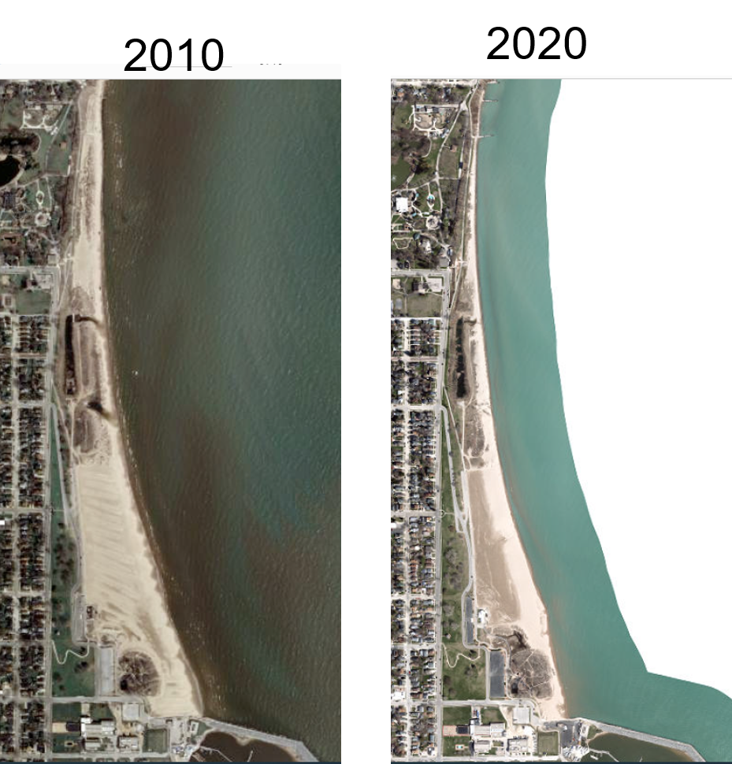
Map Data: Sources: Esri, HERE, Garmin, Intermap, increment P Corp., GEBCO, USGS, FAO, NPS, NRCAN, GeoBase, IGN, Kadaster NL, Ordnance Survey, Esri Japan, METI, Esri China (Hong Kong), (c) OpenStreetMap contributors, and the GIS User Community

In the 2010 image, the beach width, as represented by the tan sand, extends from the southeast corner of the parking lot toward Lake Michigan at a distance of approximately the width of four parking lots. The beach extends beyond the Racine Yacht Club building.
In the 2020 image, the beach width extends from the southeast corner of the parking lot toward Lake Michigan at a distance of approximately the width of two parking lots. The beach does not reach the Racine Yacht Club building. In other words, the beach width in 2020 is approximately 1/2 of what it was in 2010.
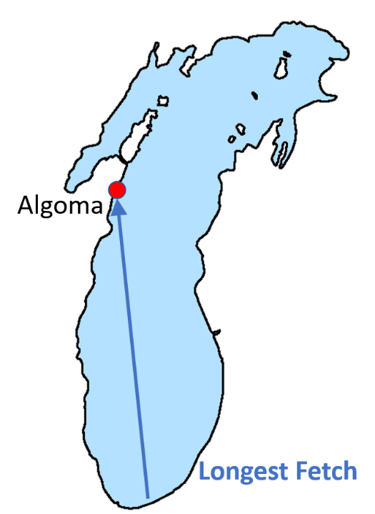
E. Comparison of Racine and Algoma Image source: Adam Bechle, Wisconsin Sea Grant
Let’s compare Racine with the city of Algoma, located much further north in Wisconsin. Here, the longest fetch is from the southeast direction. Where do you think the large beach is located in Algoma? It’s on the south side of Algoma Harbor.
Can you see this play out at other locations in Wisconsin?
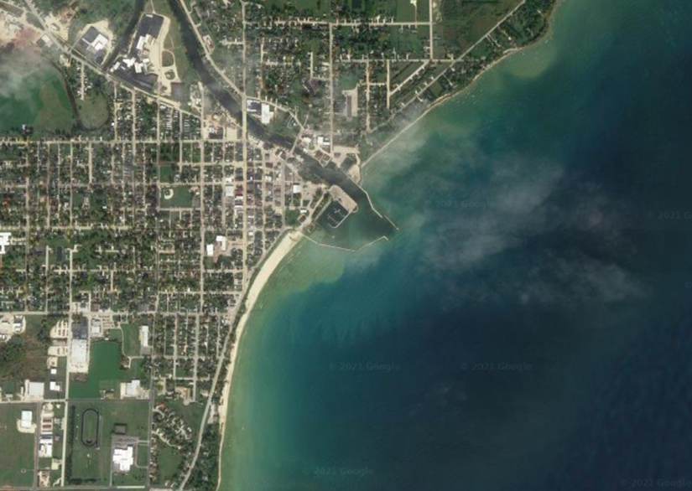
Maps Data: Google, ©2021 Maxar Technologies, USDA Farm Service Agency, Map data ©2021

