Name: Class Period: Date:

LAKE MICHIGAN WATER LEVELS — ANSWER KEY

Step 1: Based on the Lake Michigan Water Level (1920-2021) graph, provide your answers to the questions below.
- What do you think the red line in the graph represents?
The red line represents the average water level for Lake Michigan between 1920 and 2021 as measured in feet IGLD 1985.
- Approximately what is the value of the highest water level ever recorded for Lake Michigan between 1920 and 2021? 582 feet IGLD 1985
- Approximately what is the value of the lowest water level ever recorded for Lake Michigan between 1920 and 2021? 576 feet IGLD 1985
- Doing the math, what is the approximate change in water level between the highest and lowest water levels recorded for Lake Michigan between 1920 and 2021?
6 feet IGLD 1985
- Do you think water levels on Lake Michigan are static (unchanging) or vary? (Be sure to defend why you think the way you do.)
Responses will vary________________________________________________________________
___________________________________________________________________________________
___________________________________________________________________________________

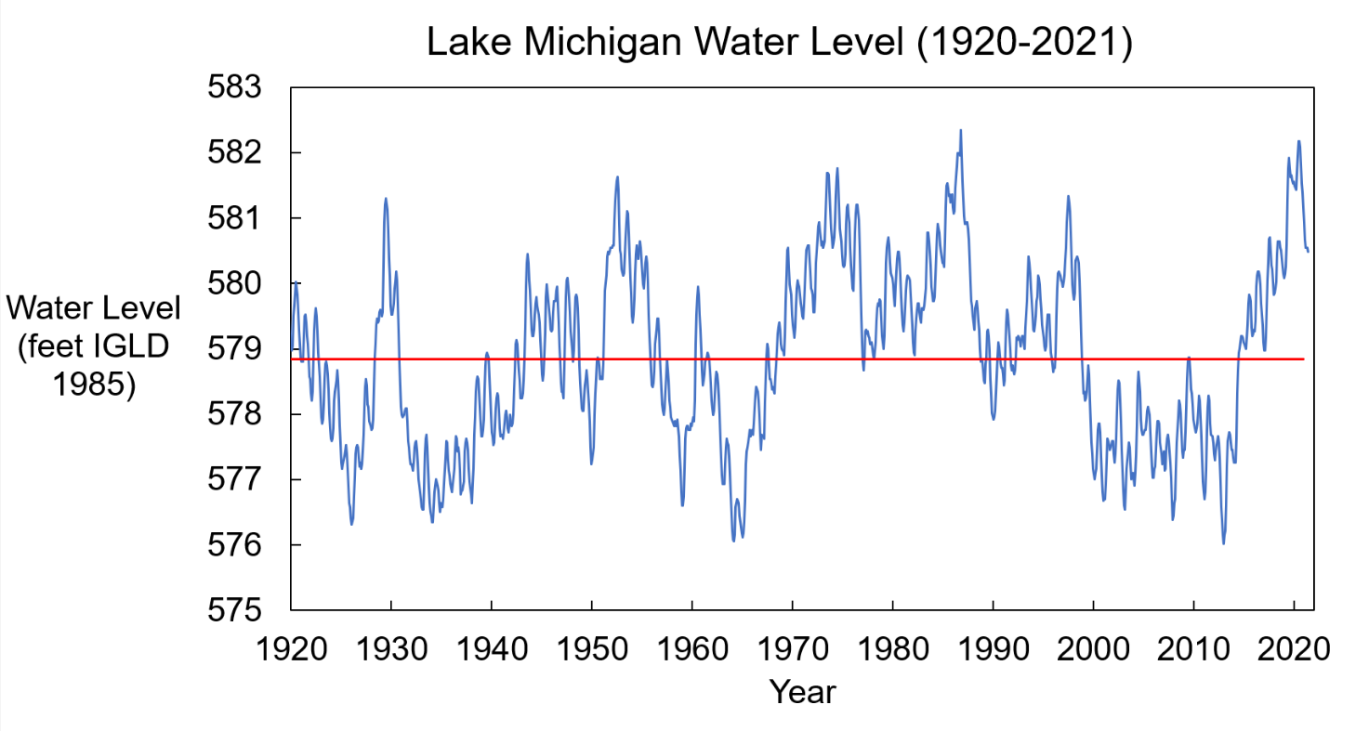
Image source: Adam Bechle, Wisconsin Sea Grant
IGLD 1985 = International Great Lakes Datum 1985

Reference
Indiana Department of Natural Resources. (2024). Lake Level Fluctuations. Retrieved June 28, 2024. https://www.in.gov/dnr/water/lake-michigan/lake-level-fluctuations

Historic Beach Width Measurement Photographs

2005
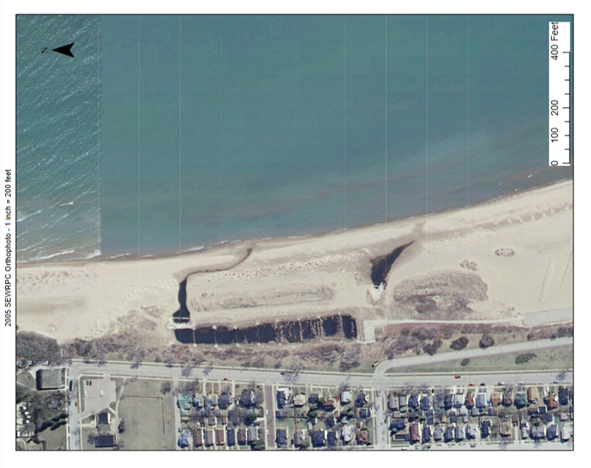
Image source: 2005 SEWRPC Orthophoto

2010
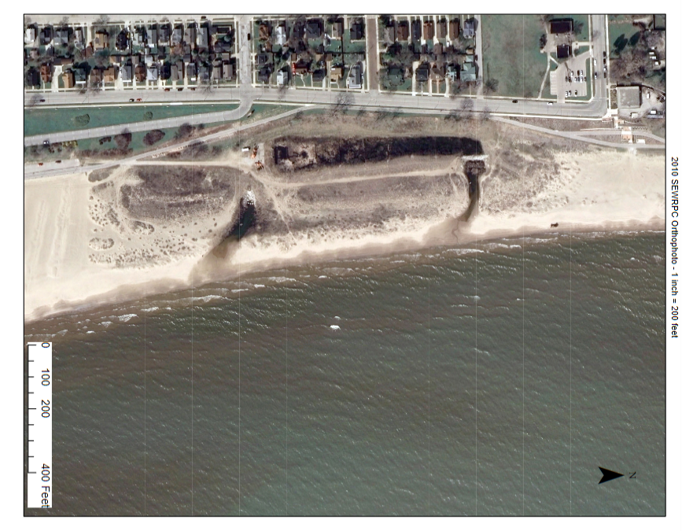
Image source: 2010 SEWRPC Orthophoto

2015
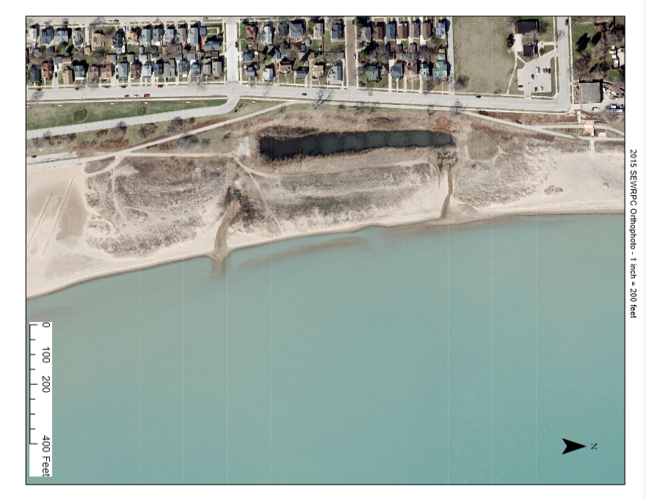
Image source: 2015 SEWRPC Orthophoto

