Name: Class Period: Date:

WATER & SEDIMENT ON THE LAKE MICHIGAN SHORELINE

Step 1: Make sure you have the needed materials.
- Wave tank (clear plastic storage container)
- Plastic measuring cup to measure sand and then water
- Sand (4 cups of fine-grain “play” sand)
- Water (2 cups to start, 1 cup to add)
- 6 in. putty scraper (device to make waves and to shape beach)
- Three dry-erase markers (black, red, green)
- Towels and/or sponge for cleanup
- Bucket for wastewater (1 per class)

Step 2: Make your coastline and document its profile.
- Dump sand into one half of your wave tank. Use your putty scraper to shape the sand into a coastline. (See figure below. It is fine if your coastline does not exactly match the figure.)
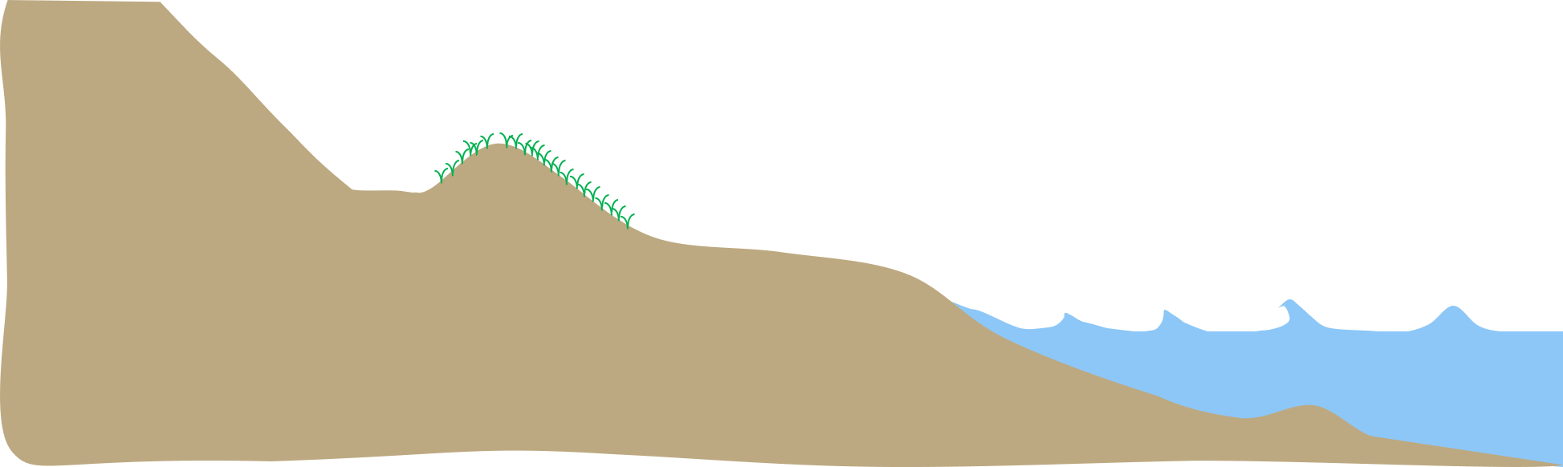
Image source: Adam Bechle, Wisconsin Sea Grant
- Using the black dry-erase marker, trace the profile of your coastline onto the outside of both of the long sides of your wave tank.
- Document your original coastline profile by also drawing it at the top of page 2 of this handout.

Step 3: Simulate a lake with low water levels by adding water to the area where there is no sand. Then create waves.

My Original Coastline Profile Drawing
- Add water (2 cups) to the open space within the wave tank to simulate the lake at a “low water level” state. Observe what happens between the sand and the water.
- Use your putty scraper to make 20 waves. (Hint: to make waves, start at the end of the tank and push water towards the beach.)
- Let the water settle.

Step 4: Observe and explain the changes to this low water level coastline profile. Record in table.
- Describe what happens to the coastline under the force of waves.
__________________________________________________________________________
__________________________________________________________________________
- Where does the sand end up?
__________________________________________________________________________
__________________________________________________________________________

Step 5: Record your low water level coastline profile observations.
- Trace the coastline profile onto the outside of both the two long sides of the wave tank with the red dry-erase marker.
- Document your low water level coastline profile by also drawing it below.

Low Water Level Coastline Profile

Step 6: Add water to simulate a lake with high water levels, and create waves.
- Add water (1 more cup) to the wave tank to simulate the lake at a high water level state.
- Use your putty scraper to make 20 waves.
- Let the water settle.

Step 7: Observe and explain the changes to this high water level coastline profile.
- Describe what happens to the coastline under the force of waves.
__________________________________________________________________________
__________________________________________________________________________
__________________________________________________________________________
- Where does the sand end up?
__________________________________________________________________________
_________________________________________________________________________

Step 8: Record your high water level coastline profile.
- Trace the coastline profile onto the outside of both of the long sides of the wave tank with the green dry-erase marker.
- Document your high water level coastline profile by also drawing it below.

My High Water Coastline Profile

Step 9: Comparison with other groups (optional).
- Participate in a discussion with members from one or more other groups. Questions to consider:
- How did the original coastline profile your group created (black dry-erase line) compare with the original coastal profile the other group(s) created?
- How did the coastal profile at your “low water level” state (red dry-erase line) compare with the low water level coastal profile the other group(s) created?
- How did the coastal profile at your “high water level” state (green dry-erase line) compare with the high water level coastal profile the other group(s) created?

Step 10: Time to clean up.
- Slowly and carefully drain the wave tank water into the wastewater bucket, being careful to keep the sand in the tank. DO NOT pour the water down the drain. Please drain as much water as possible.
HINT: Use the plastic measuring cup to scoop out the last bit of water.
- Use a damp towel or sponge to erase the lines on the outside of the wave tank box.
- Spread out sand within the plastic box and leave it to dry for tomorrow.

Step 11: Questions to Explore.
- How does an increase in water levels change erosion?
- How might you slow erosion (the movement of sand away from the original coastline)?
- How might you control sediment transport (influence where the sand ends up)?

