LESSON 3

COASTAL ENGINEERING STRUCTURES — PROTECTING THE SHORELINE
BACKGROUND INFORMATION
Contents
- What are the solutions and services of coastal engineering?
- Seven common engineering solutions that coastal engineers employ
- The benefits, challenges, and design considerations for each solution
- Our engineering field site: North Beach, city of Racine

What Are the Solutions and Services of
Coastal Engineering?
Some human uses of coastal property and the nearshore area include residential (homes), recreation (beaches, boating) and shipping. When natural coastal processes like waves, currents and erosion hinder these uses of the coast, coastal engineers design, construct and carry out solutions to support continued human use of these areas. In other words, the focus of coastal engineering is to support human use of the coast by designing and constructing solutions to protect and enhance the shoreline.
Coastal engineering approaches include:
- Constructing coastal structures, which protect the coast from the forces of waves, water levels, currents and erosion.
- Dredging, which is the excavation of material from a waterway. Dredging is commonly done to make the water deep enough for ships and boats.
- Creating coastal habitats, which is building islands, wetlands, dunes, reefs and other features to support coastal ecosystems.
These solutions aim to provide one, or more, of the following services:
    - Flood control, which uses structures, drainage and land use decisions to reduce the impact of flooding from waves and water levels.
    - Erosion control, which uses structures and vegetation to slow erosion.
    - Erosion management, which is the planning of human uses on the coast to avoid the impacts of coastal flooding and erosion rather than resist them.
    - Beach stabilization, which includes the building of beaches.
    - Habitat creation
    - Water quality protection and improvements

B. Seven Common Engineering Solutions that Coastal Engineers Employ
There are seven common types of coastal engineering solutions around the Great Lakes:
- Revetments*
- Seawalls*
- Jetties*
- Breakwaters*
- Beach nourishment
- Nature-based shorelines*
- Relocation
*Solutions found near North Beach
These coastal engineering solutions are described in more detail within the next section.
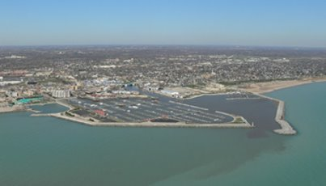
Image source: David Mickelson, Wisconsin Coastal Management Program

C. The Benefits, Challenges, and Design Considerations for Each Solution

Revetment
Revetment Considerations
Benefits: durable and reliable structure if well designed and constructed.
Challenges: covers some or the entire beach with large rock; can cause increased erosion at neighboring properties.
Design considerations: wave height, water depth, water levels, stone size, stone material, revetment slope, revetment height.
Interlocking pieces of stone or concrete on a gentle sloping face built to directly protect the shore from erosion. Its purpose is to armor the shore to protect against erosion.

*Design hint – a revetment with only large stone will let sediment erode between the large gaps between the stones. Well-designed revetements have a “filter layer” of smaller stone that holds the underlying sediment in place. The larger “armor stones” resist the forces of the waves and prevent the smaller stones of the filter layer from being washed away.
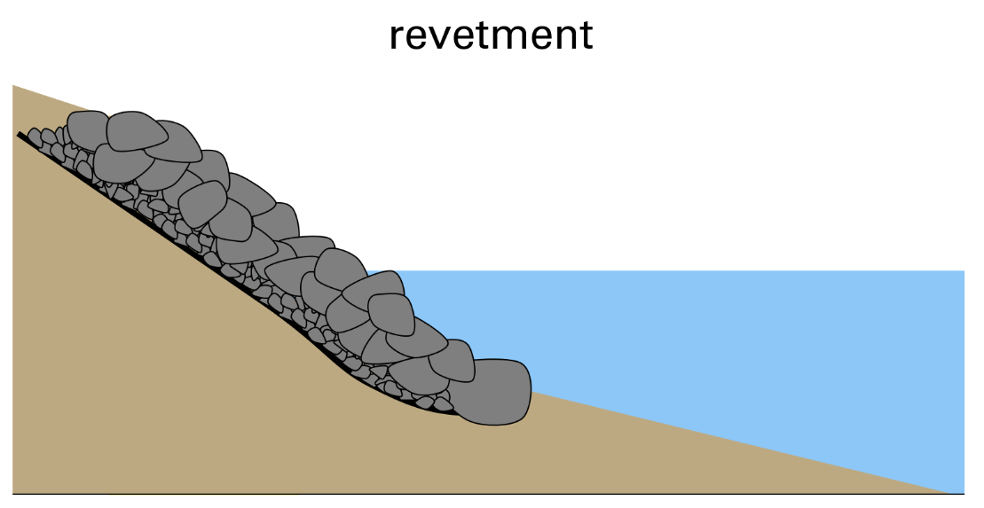
Image source: Adam Bechle, Wisconsin Sea Grant

Seawall
Seawall Considerations
Benefits: durable and reliable structure if well designed and constructed.
Challenges: vertical wall reflects a lot of wave energy, creating rough waters in front of wall; can cause increased erosion at neighboring properties.
Design considerations: wave height, water depth, water levels, soil forces behind seawall, scour protection at the wall’s base.

A vertical concrete, steel or stone wall that directly armors the shore to protect it from erosion. Its purpose is to directly armor the shore to protect against erosion.
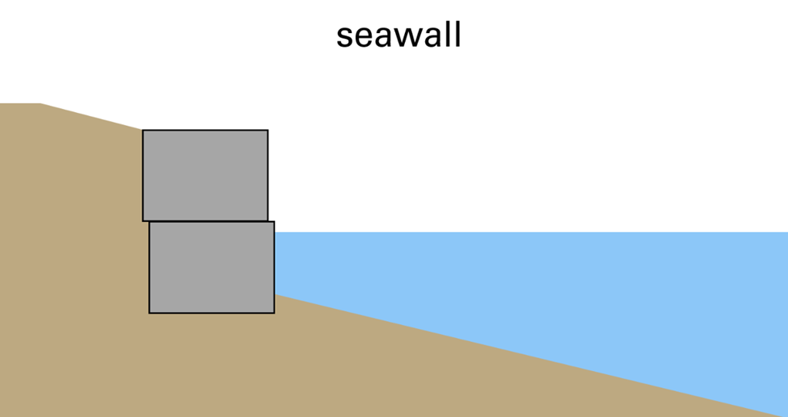
Image source: Adam Bechle, Wisconsin Sea Grant

Jetty
Jetty Considerations
Benefits: helps protect shore by building a beach that can also be used for recreation.
Challenges: increases erosion on downstream side by blocking alongshore sediment transport; high water levels can submerge the beach, making it less effective at breaking wave energy.
Design considerations: water depth, wave direction, water levels, jetty length, space between jetties, amount of alongshore sediment transport available to build the beach (if not much sand is being transported, not much beach will be built).
Stone or concrete structure built perpendicular to the shore to trap sand and hold beach material in place. Its purpose is to trap sand and build the beach. The beach is intended to break waves and reduce wave energy before it reaches the upland.
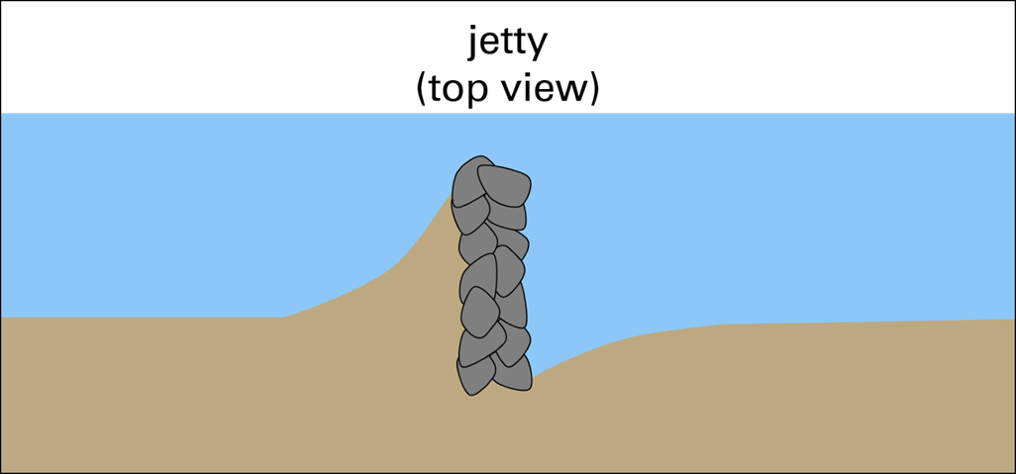
Image source: Adam Bechle, Wisconsin Sea Grant

Breakwater
Breakwater Considerations
Benefits: does not directly armor the shore with rock, potentially allowing for a beach.
Challenges: very expensive due to the large quantity of materials and in-water construction; can increase erosion at neighboring properties.
Design considerations: wave height, water depth, water levels, stone size, breakwater slope, length of breakwater, space between breakwaters.
Stone or concrete structure built perpendicular to the shore to trap sand and hold beach material in place. Its purpose is to trap sand and build the beach. The beach is intended to break waves and reduce wave energy before it reaches the upland.
*Design hint – a breakwater constructed of only large stone will allow a large amount of wave energy to pass through it due to the large gaps between the stone. A well-designed breakwater uses a “core layer” of smaller stone that will have smaller gaps to block this wave energy. The larger “armor stone” resists the forces of the waves and prevents the smaller stones of the core layer from being washed away by the waves.
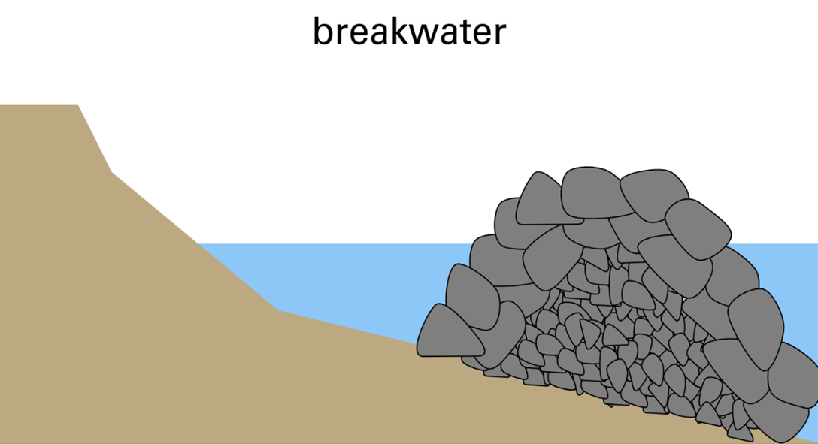
Image source: Adam Bechle, Wisconsin Sea Grant

Beach & Dune Nourishment and Building
Beach & Dune Nourishment and Building Considerations
Benefits: builds the beach, which can be used for recreation, can provide sand to neighboring beaches through alongshore sediment transport.
Challenges: likely requires future nourishment as erosion removes sand over time.
Design considerations: wave height, water levels, beach slope, sediment sizes, finding a source of sediment.
The placement of clean sediment, often sand, on beaches, dunes or in nearshore waters. Its purpose is to compensate for sand lost due to erosion or to build larger beaches and dunes.
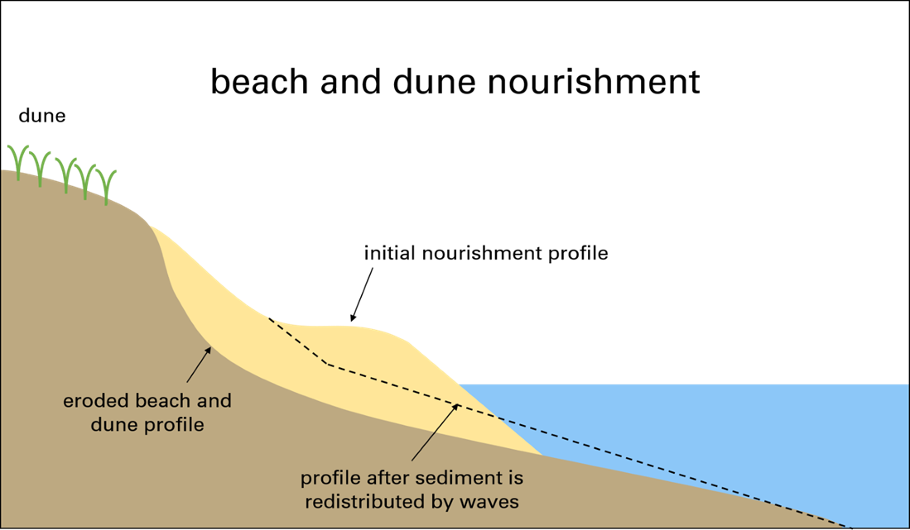
Image source: Adam Bechle, Wisconsin Sea Grant

Nature - Based Shorelines
Nature - Based Shoreline Considerations
Benefits: provides habitat for fish and wildlife.
Challenges: natural features like vegetation need to be cared for and maintained.
Design considerations: wave height, water levels, ice, plant growth conditions (climate, growing seasons, soil moisture, sun exposure).
Stone or concrete structure built perpendicular to the shore to trap sand and hold beach material in place. Its purpose is to trap sand and build the beach. The beach is intended to break waves and reduce wave energy before it reaches the upland.
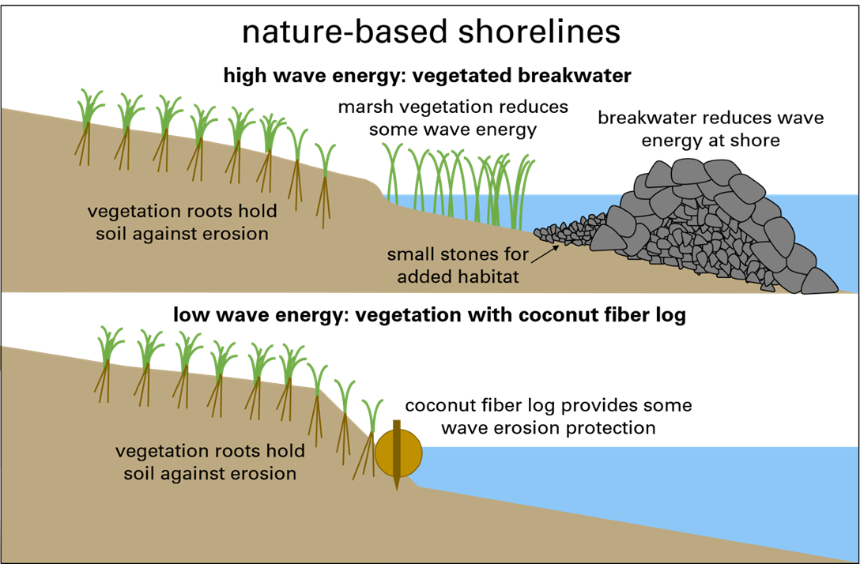
Image source: Adam Bechle, Wisconsin Sea Grant

Relocation
Relocation Considerations
Benefits: can be the cheapest way to protect a home; allows a natural shoreline.
Challenges: may not be enough space to move a home far enough away from eroding coast to keep it safe.
Design considerations: where and how far away from coast to relocate (based on erosion rate), path for relocation, ease of moving the building (larger, more complex buildings can take more effort) reconnecting utilities such as water, sewer, electricity, etc.
Moving a home or other building away from an eroding or flooding coast. Its purpose is to protect the building while allowing erosion or flooding to occur naturally. This can sometimes be the cheapest way to protect a home.
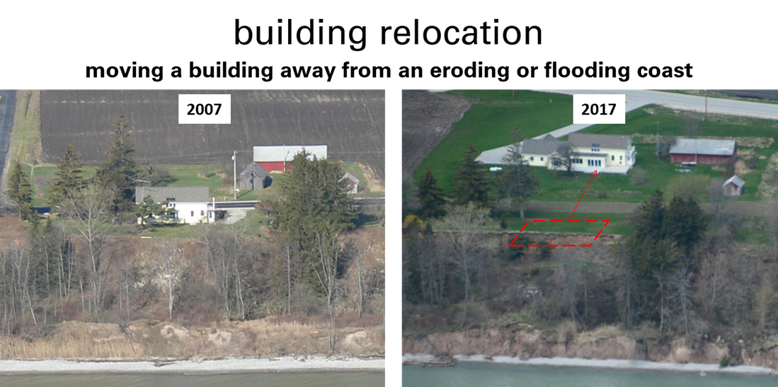
Image sources: 2007 – Dave Mickelson, 2017 – Capt. Dennis Carr, Wisconsin Wing, Civil Air Patrol

D. Our Engineering Field Site: North Beach, City of Racine

One major focus of coastal engineering in the Racine area has been the design and construction of coastal structures, which were built to withstand the forces of waves, currents and erosion. The forces of waves, currents, and erosion can change with changes in water levels. The design of coastal structures involves the analysis of the coastal process that may impact a site, as well as the coastal landscape and its intended use. These structures are sometimes referred to as “gray infrastructure” or “armoring.” 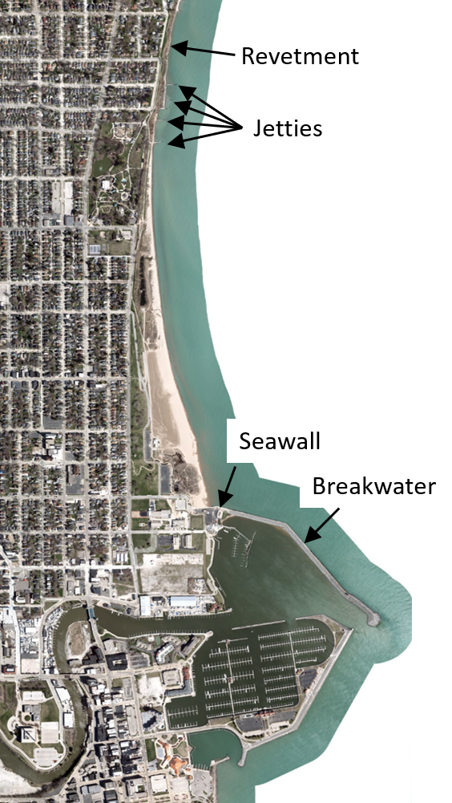
Map Data: Esri, HERE, Garmin, Intermap, increment P Corp., GEBCO, USGS, FAO, NPS, NRCAN, GeoBase, IGN, Kadaster NL, Ordnance Survey, Esri Japan, METI, Esri China (Hong Kong), (c) OpenStreetMap contributors, and the GIS User Community
Coastal structures around the North Beach area include:
Racine Harbor Breakwaters: Racine Harbor consists of two breakwaters (north and south) which provide an area within the harbor that is sheltered from waves and currents for boats.
Racine Harbor Seawall: A steel seawall connects the harbor breakwater to the shore at the south end of North Beach.
Zoo Beach Jetties: These jetties trap some sand to build beach. They are old and in poor shape, so they are not very effective at trapping sand. Some downdrift erosion is noticeable at high water levels.
Zoo Beach Revetment: Protects the bluff in front of Michigan Boulevard.
In more recent years, coastal habitat creation and nature-based shorelines at North Beach have also been introduced as ways to control flooding, manage erosion and stabilize the beaches. These solutions, considered to be green infrastructure, will be covered in lesson 5. In this lesson we will focus on the built structures, jetties and breakwaters. Green infrastructure often uses a combination of green and gray features (like rock) to provide the needed level of protection from erosion or flooding.

