COASTAL ENGINEERING STRUCTURES —
ANSWER KEY

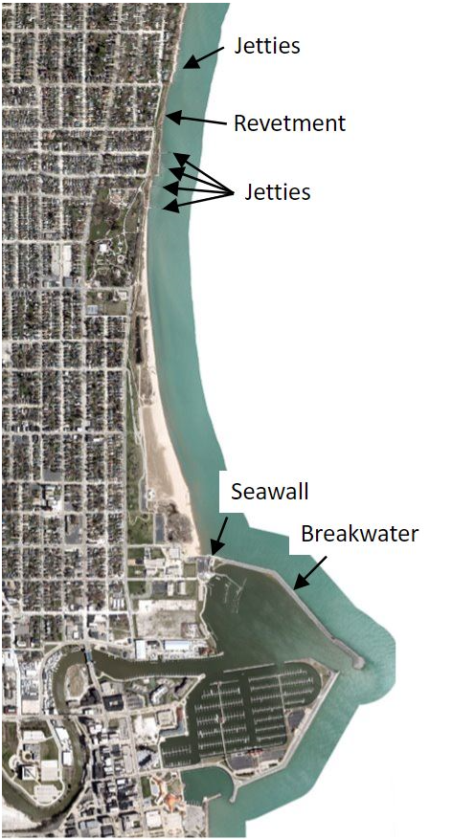

Map Data: Esri, HERE, Garmin, Intermap, increment P Corp., GEBCO, USGS, FAO, NPS, NRCAN, GeoBase, IGN, Kadaster NL, Ordnance Survey, Esri Japan, METI, Esri China (Hong Kong), (c) OpenStreetMap contributors, and the GIS User Community

