Team Name:
Team Members’ Names:
Class Period: Date:

USING THE ENGINEERING DESIGN PROCESS (EDP)
TO DESIGN A COASTAL STRUCTURE

Step 1: Make sure your team has the needed materials.

Wave Tank Supplies
- Wave tank (clear plastic storage container)
- Sand (4 cups plus extra for rebuilding profile or to conduct nourishment)
- Measuring cup for solids (if sand not pre-measured)
- Water (3 cups)
- Measuring cup for liquids
- 6” putty scraper (device to make waves and to shape beach)
- Three dry-erase markers (black, red and green)
- Two toy houses
- Rocks (different types – small gravel, round stones, angular stones
- Blocks or plastic sheets (to represent seawall)
- Towel/sponge for cleanup

Step 2: Create a sand profile within your wave tank.

Typical beach profile
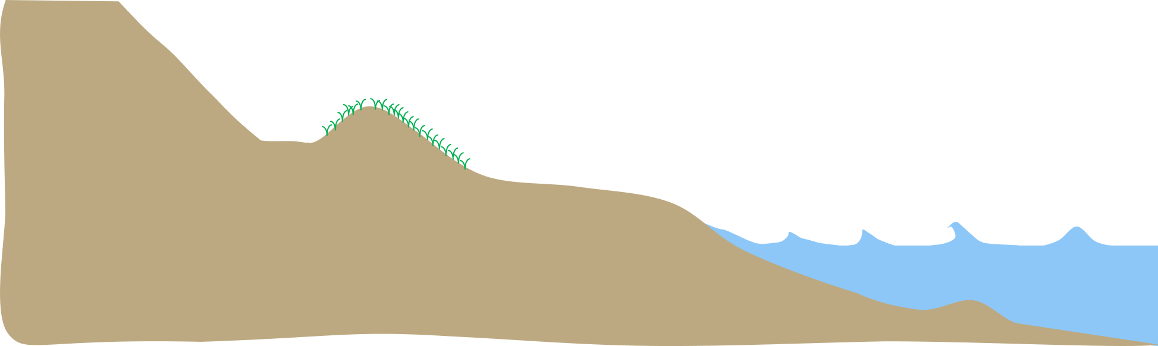
Image source: Adam Bechle, Wisconsin Sea Grant

To begin:
- Dump 4 cups of sand into the wave tank and use 6” putty scraper to shape it into a beach. An example of a beach profile is above.
- Make a line on each long side of the wave tank with the black dry-erase marker to trace the starting shape of your beach.
- Add your houses in a realistic location.
- Add low-level lake water #1 (2 cups) to the tank in the area where there is no sand.
- Study the four coastal engineering structures (last four pages of this handout) that you can employ to protect your house and discuss with your team a possible solution.

EDP 1: Define the problem. What do you want to solve?
How can we design a coastal engineering structure that

EDP 2: Identify design requirements. What are your criteria and constraints?
We want our coastal engineering structure to

Additional considerations we have:

EDP 3: Each team member brainstorms and then sketches two possible coastal engineering solutions, considering the four coastal engineering structure types (see last 4 pages of handout) and your available materials.
Name and drawing of my Design Solution #1
Name and drawing of my Design Solution #2

EDP 4: Analyze pros and cons of these two solutions and list them. Discuss as a team.

EDP 5: Select a design.
We have chosen this design solution:
Because:

EDP 6: Build a prototype of chosen coastal engineering design solution. You will have 3 minutes.
EDP 7: Test your coastal engineering design solution.
To complete step 7, use the following steps:
- Use a putty scraper to make 20 waves (hint: move the water from one end of the tank toward the beach). Be sure to observe the way the sand and water move along the beach. Make notes in the “testing observations'' section, Step 7 of the EDP handout.
- Observe beach profile and trace it on the long sides of the wave tank with the red dry-erase marker.
- Add high-level lake water #2 (+ 1 cup) to the wave tank.
- Use a 6” putty scraper to make 20 waves.
- Observe beach profile and trace it on the long sides of the wave tank with green dry-erase marker.
- Add any additional testing observations after step 7 in the EDP handout.
- Discuss with your group any design changes you might want to introduce.
- Construct any modifications to your structure and test again with more waves (if time allows).

Step 3: Time to clean up.
- Remove rocks and other engineering structures and lay out to dry.
- Drain wave tank of as much water as possible (without dumping sand down the drain).
- Erase lines on box.
- Spread out sand in the box and leave it to dry.

Step 4: Questions to explore.
- Did your design protect the houses?
- What improvements did you make to your design (or wanted to make, if you ran out of time)? Why did you make these improvements?
- Were all areas of the shoreline protected equally by your engineered structure? If not, how did the shoreline change in areas that were not equally protected by the engineered structure?
- How did the sand and water move when waves hit the beach at low water levels (#1)? Did you observe any difference at high water levels (#2)?
- The cost of a coastal structure is usually related to the amount of materials used. Can you think of any ways you could have reduced costs while still protecting the houses?
- How would your design affect a person’s ability to enjoy the beach?

FOUR COASTAL ENGINEERING STRUCTURES FOUND AT NORTH BEACH, CITY OF RACINE

Number 1 - Revetment
Revetment Interlocking pieces of stone or concrete on a gentle sloping face built to directly protect the shore from erosion. Its purpose is to directly armor the shore to protect against erosion.
- Benefits: durable and reliable structure if well designed and constructed.
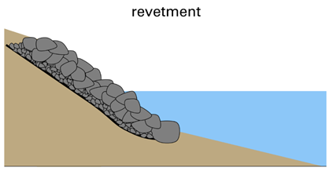
- Challenges: cover some or the entire beach with large rock; can cause increased erosion at neighboring properties.
- Design Considerations: wave height, water depth, water levels, stone size, stone material, revetment slope, revetment height.

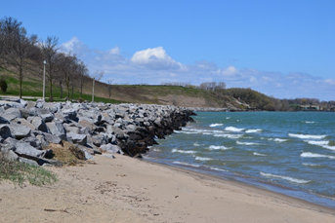
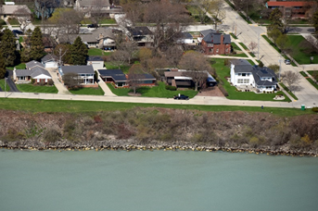
Number 2 – Seawall
Example 2: Revetment at Bender Park, Oak Creek
Image source: Adam Bechle, Wisconsin Sea Grant
Example 1: Revetment at Zoo Beach
Image source: Capt. Dennis Carr
Seawall A vertical concrete, steel or stone wall designed to protect the shore from erosion. Its purpose is to directly armor the shore to protect against erosion.
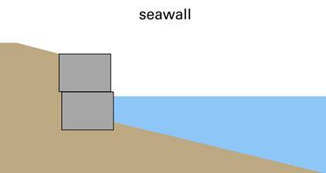
- Benefits: durable and reliable structure if well designed and constructed.
- Challenges: vertical wall reflects a lot of wave energy, creating rough waters in front of wall; can cause increased erosion at neighboring properties.
- Design Considerations: wave height, water depth, water levels, soil forces behind seawall, scour protection at the wall’s base.

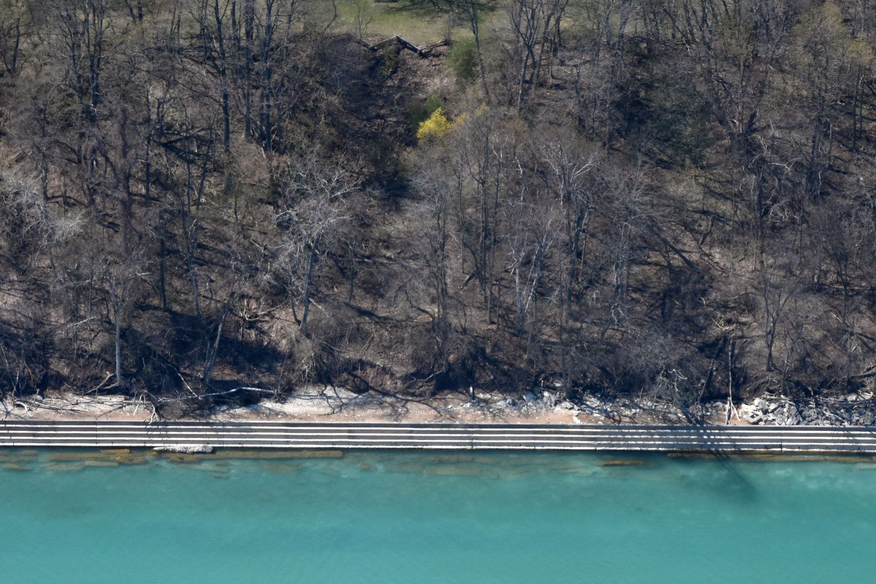
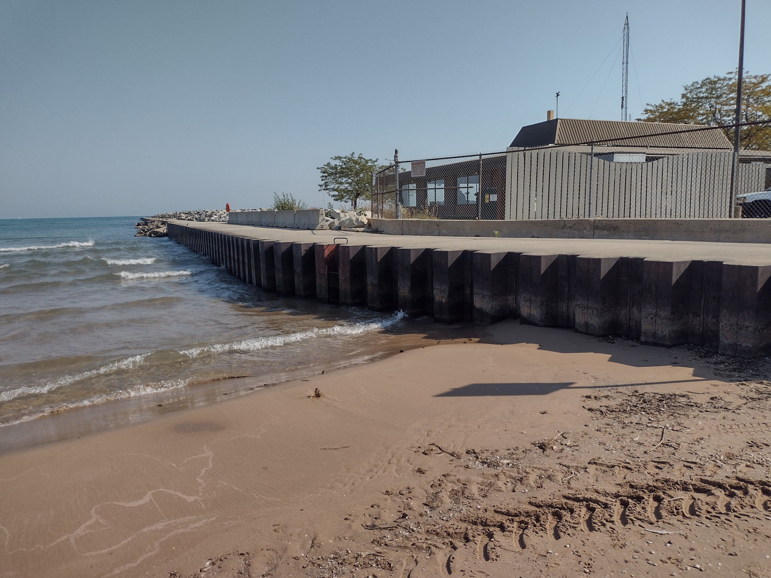
Number 3 – Jetty
Example 2: Concrete Seawall near Milwaukee
Image source: Capt. Dennis Carr
Example 1: Steel Seawall at North Beach
Image source: Adam Bechle, Wisconsin Sea Grant
Jetty A stone or concrete structure built perpendicular to the shore to trap sand and hold beach material in place. Its purpose is to trap sand and build the beach. The beach is intended to break waves and reduce wave energy before it reaches the upland.
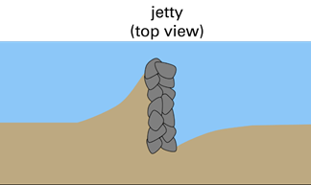
- Benefits: helps protect shore by building a beach that can be used for recreation.
- Challenges: increases erosion on downstream side by blocking alongshore sediment transport; high water levels can submerge the beach, making it less effective at breaking wave energy.
- Design Considerations: water depth, wave direction, water levels, jetty length, space between jetties, amount of alongshore sediment transport available to build the beach (if not much sand is being transported, not much beach will be built).
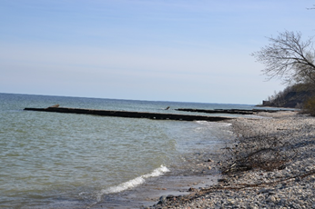
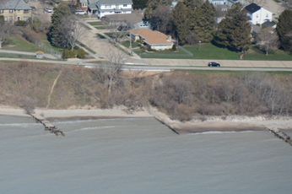
Example 2: Jetties at Sheridan Park
Credit: Adam Bechle
Example 1: Jetties at Zoo Beach
Credit: Capt. Dennis Carr

Number 4 – Breakwater
Breakwater Stone or concrete structure built off shore to block or reduce wave energy behind it. Its purpose is to block or reduce wave energy before it reaches the shore. This may allow for natural features like a beach or vegetation to establish. Breakwaters are also used to create sheltered harbors for boats and ships.
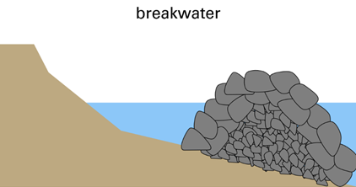
- Benefits: does not directly armor the shore with rock, potentially allowing for a beach.
- Challenges: very expensive due to large amounts of materials and in-water construction; can increase erosion at neighboring properties.
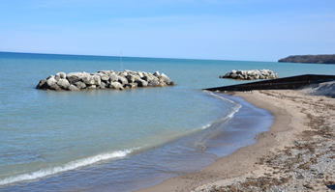
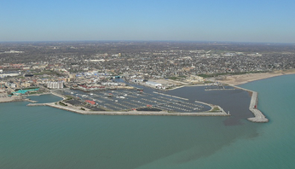
- Design Considerations: wave height, water depth, water levels, stone size, breakwater slope, length of breakwater, space between breakwaters.
Example 1: Breakwaters protecting Racine Harbor
Credit: Dave Mickelson
Example 2: Breakwaters at Klode Park, Whitefish Bay, WI
Credit: Adam Bechle

