LESSON 4

STORMWATER MANAGEMENT
BACKGROUND INFORMATION
Contents
- What is stormwater?
  - Recall the natural water cycle
- What is stormwater management?
  - How have humans changed the water cycle?
- Our engineering field site: North Beach, city of Racine

What Is Stormwater?
Rain and snow are two types of precipitation. Once on the ground, water from rain, a snowstorm, or other forms of precipitation is called stormwater. The stormwater can take three paths. The first path is the movement of water from the land surface back to the atmosphere through the processes of evaporation and transpiration. The second path is infiltration into soil and ultimately percolating through the soil and replenishing aquifers within the groundwater system. The third path is flowing across the surface of the landscape in a process called “runoff.” Because of gravitational forces, this runoff water flows down slope into streams, rivers, and lakes. Ultimately, water within Lake Michigan may even outflow through the other Great Lakes and eventually end up in the Atlantic Ocean.

Recall the natural water cycle.
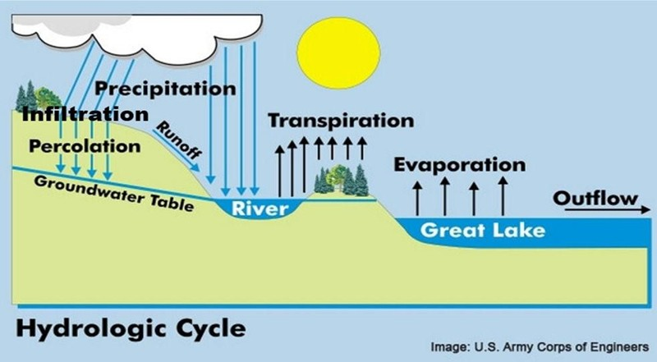Image source: U.S. Army Corps of Engineers

What Is Stormwater Management?
The following are ten typical components of the hydrologic cycle.
- Evaporation The process of changing from liquid to gas. Evaporation releases water on the land and in lakes and rivers into the atmosphere.
- Groundwater Water beneath the ground. Groundwater flows through the spaces between soil particles or cracks in bedrock, which is the rock layer below the ground.
- Groundwater table The boundary (not a straight line) between the saturated zone (where water fills the space between soil particles) and the unsaturated zone (where air fills the space between soil particles).
- Infiltration Movement of water into the ground. How fast water flows into the ground is called the infiltration rate.
- Inflow An addition of water to a particular portion of the hydrologic system of the watershed, for example, water flowing in from an upstream lake.
- Outflow A removal of water to a particular portion of the hydrologic system of the watershed, for example, water flowing out to a downstream lake.
- Percolation Movement of water through the ground.
- Precipitation Water that falls from the sky, typically in the form of rain, snow, sleet, or hail.
- Runoff Water that drains off the land. Water runs off the land when the rate of precipitation is greater than the combined infiltration, evaporation, and transpiration rates.
- Transpiration The process of water movement through a plant. Plants' roots take up water, which is transferred to the stems and leaves. The leaves of a plant transpire water into the atmosphere.
Stormwater management is the control and use of components of the hydrologic cycle - water evaporation, transpiration, infiltration, percolation, and runoff - especially water that results from storms (precipitation) events. It includes planning for the movement of water, maintaining stormwater infrastructure systems, and regulating the collection, storage, and movement of water. Stormwater management also considers drainage (infiltration and percolation) in the design of cities and housing developments.

How have humans changed the water cycle?
The water cycle is modified by three human activities: 1) by building and constructing on the landscape, which influences infiltration; 2) by engineering stormwater management infrastructure such as storm sewers to manage runoff flow patterns; and 3) by altering where and how long water is located within each stage of the hydrologic cycle. For example, where water is located and how long it remains there may be influenced by engineering and constructing structures such as retention (holding) ponds and water treatment plants designed to remove pollutants from groundwater or surface water.

By building and constructing on the landscape we’ve changed how water moves into the ground (infiltration) and across the landscape (runoff)
- Pervious surface – a surface that water can flow through. Pervious surfaces include lawns, forests and fields. Some water that falls on a pervious surface can infiltrate into the ground. The remaining water moves across the landscape as runoff.
- Impervious surface – a surface that water cannot flow through. Impervious surfaces include roofs, streets and parking lots. Precipitation that falls on an impervious surface and does not evaporate becomes runoff.

Comparing pervious and impervious surfaces
Comparison of these two illustrations shows that increases in the built environment result in decreased infiltration rates (from the original 50% to 15%) and increases in runoff rates (from the original 10% to 55%). These changes to the water balance have significant ramifications on flooding risk often contributing to localized flooding and flooding around waterways.
Another significant impact resulting from this alteration from a natural environment to a built environment is the increased presence of pollutants in our water systems. Stormwater runoff is a leading cause of water pollution in urban and suburban areas due to the high percentage of impervious surfaces such as roadways, parking lots, and rooftops. When it rains, stormwater washes over these impervious surfaces, picking up sediment, oil and grease, heavy metals, bacteria, trash, and other pollutants from the urban landscape. This runoff flows into stormwater collection systems (gray infrastructure) and discharges into local streams, negatively impacting water quality in the local watershed.
Modified from image source: Commonwealth of Massachusetts: https://www.mass.gov/service-details/smart-growth-smart-energy-toolkit-modules-low-impact-development-lid
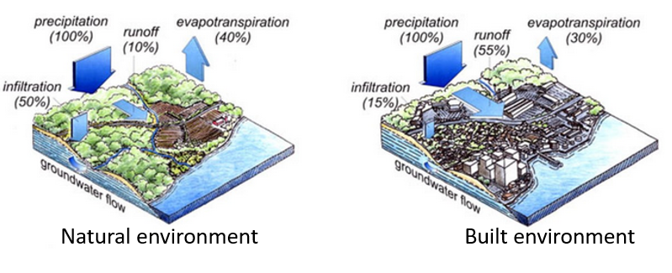

By engineering storm sewer systems to manage runoff
To deal with stormwater runoff, especially the higher flow of runoff that has resulted from the increased use of impermeable surfaces, a system of storm drains and pipes is often built to collect and transport runoff to a drainage point. Storm sewers often drain directly into a lake, river or other water body.
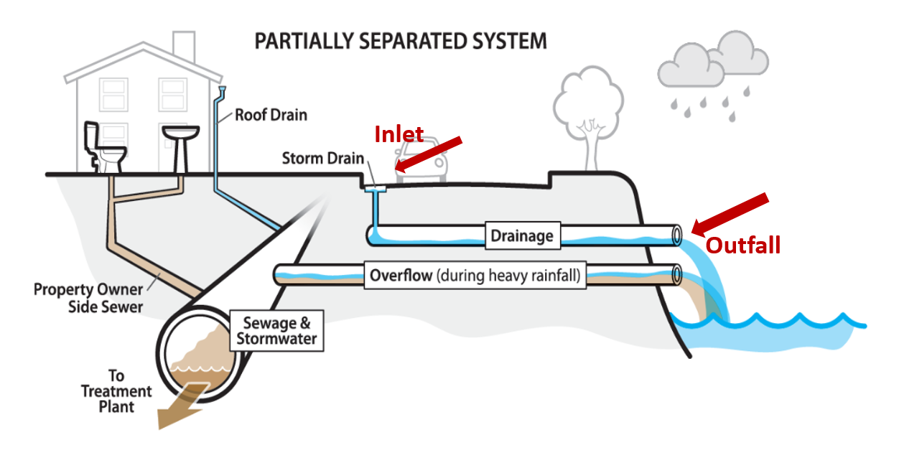Image source: City of Seattle: https://www.seattle.gov/Documents/Departments/SPU/CRPDWWOverview10122016.pdf
A storm sewer system is designed to be able to drain runoff during large rainstorms from streets, discharge runoff at a slower rate to avoid causing flooding, and remove pollutants. To do this, engineers consider the following:
Stormwater System Terms
Inlet A point that collects runoff into the storm sewer pipes. Also known as a catch basin.
Outfall A point where a storm sewer empties into a lake, river or other water body.

- Precipitation rate
- Soil infiltration rate
- Drainage area
- Potential pollutant load

By creating retention ponds to contain pollutants and help mitigate flooding and contain pollutants
Runoff can carry pollutants, bacteria and nutrients from the land surface to the water. For example:
- Road and parking lot runoff can carry gasoline, oil and trash.
- Residential lawn runoff can carry fertilizer, pet waste, leaves and trash.
- Farm field runoff can carry manure and sediment.
Altering the water cycle by holding runoff water in retention ponds (also called stormwater ponds) is one way to remove pollutants from water and reduce flooding. Stormwater ponds, which temporarily store the stormwater and slowly release it to a lake, river, or other water body help solids settle out of the water before it reaches the final water body.
Specially designed pipe systems can also remove solids. Wetlands can also help clean water. Wetland plants and bacteria growing in and along the perimeter of the retention pond break down pollutants. Since the city of Racine gets its drinking water from the Root River and Lake Michigan, engineered retention pond structures can help protect water quality.
Pollutants can contaminate waters that we drink and recreate in with harmful chemicals. Nutrients like phosphorus and nitrogen from fertilizer, manure and leaves can fuel algae blooms, which are unappealing and potentially toxic. Bacteria like E. coli from pet waste can cause illness.
Flooding can be of particular worry around the city of Racine. During and after precipitation events, stormwater runoff contributes to localized flooding and flooding around waterways. Besides serving as settling tanks, retention ponds serve to simply hold water, thus reducing the amount of water flooding landscapes.
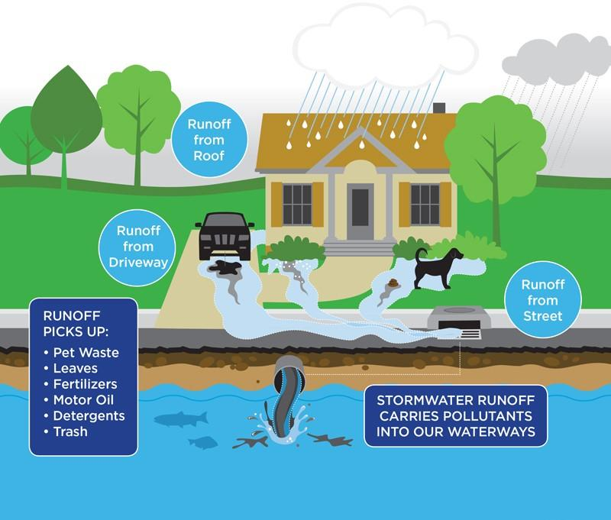
Image source: Town of Maynard, MA.
https://www.townofmaynard-ma.gov/wp-content/uploads/2018/06/stormwater-diagram.jpg
More recently, engineering has been using innovative techniques that work with nature through the implementation of green infrastructure to manage flooding from stormwater and improve water quality. These green infrastructure solutions will be the focus of lesson 5.

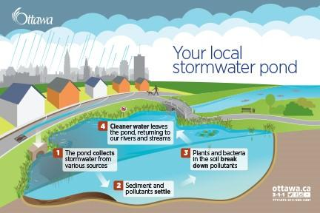
Image: City of Ottawa https://ottawa.ca/sites/default/files/16-155_stormwater-pond_postcard_e-front.jpg

C. Our Engineering Field Site: North Beach, City of Racine
All the runoff in Racine eventually goes to Lake Michigan in one of three ways.
- Directly through runoff into Lake Michigan
- Through storm sewer pipes with outfalls that drain into Lake Michigan
- Through storm sewer pipes with outfalls that drain into the Root River, which then drains into Lake Michigan

How does stormwater runoff get to North Beach?
A storm sewer outfall is located between North Beach and Zoo Beach. This outfall is known as the English Street Outfall. This outfall drains stormwater runoff from the nearby land directly into Lake Michigan. There are also two storm sewer outfalls located north of Zoo Beach that also drain directly into Lake Michigan.

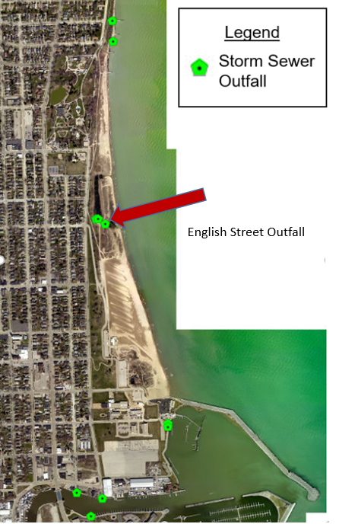
Image source: City of Racine Geographic Information System https://gis.cityofracine.org/RacineGIS/

The English Street Outfall used to discharge untreated stormwater directly to the beach. This untreated stormwater often was high in harmful bacteria (E. coli) and had a negative impact on water quality at the beach. In 2001, this outfall was reconstructed with an underground treatment system and an engineered wetland to remove pollutants from the runoff before it got to the beach. This treatment system (among other efforts).has been very successful in improving water quality at North Beach.
Other stormwater runoff from across the city drains into the Root River through many outfalls along the river’s length. This stormwater is then discharged from the mouth of the Root River into Lake Michigan. Once in the lake, this runoff can be transported to the North Beach area by currents and waves.
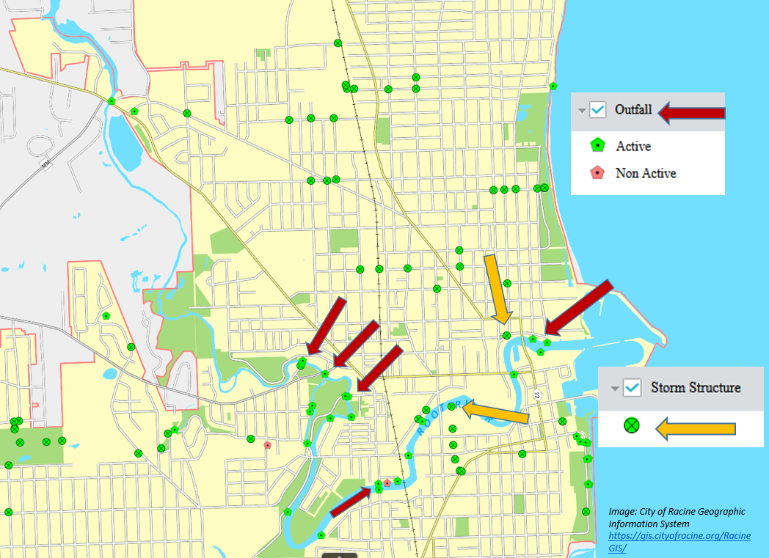
Image source: City of Racine Geographic Information System https://gis.cityofracine.org/RacineGIS/

