LESSON 5

INTRODUCTION TO
GREEN INFRASTRUCTURE
BACKGROUND INFORMATION
Contents
- What is green infrastructure?
- Our engineering field site: North Beach, city of Racine
- Native vegetation planted on bluff
- English Street infiltration basins
- An engineered dune and swale wetland

What Is Green Infrastructure?
Green infrastructure is a set of practices that incorporate natural systems to manage stormwater infiltration and runoff. Green infrastructure can use plants, soil systems, permeable surfaces, or landscaping to store stormwater or alter infiltration, evapotranspiration, and/or filtration rates of stormwater. Green infrastructure can reduce stormwater flows to sewer systems or to surface waters and improve the water quality of stormwater.

Examples of green infrastructure
When the focus is increased infiltration
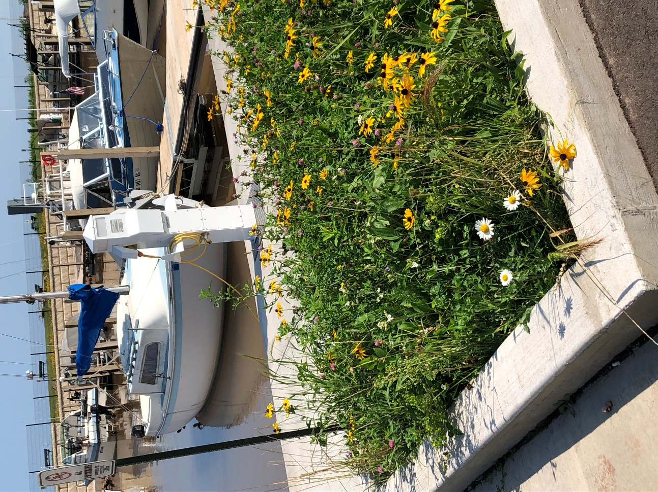
- Permeable Pavement
When the focus is decreased runoff
- Downspout Disconnection
- Rainwater Harvesting
When the focus is decreased runoff and enhanced transpiration
- Rain Gardens
- Planter Boxes
- Bioswales
- Green Streets and Alleys
- Green Parking Lots
- Green Roofs
- Trees, especially those trees with a large canopy
- Land Conservation
- Nature-Based Shorelines
Image source: Theresa Qualls

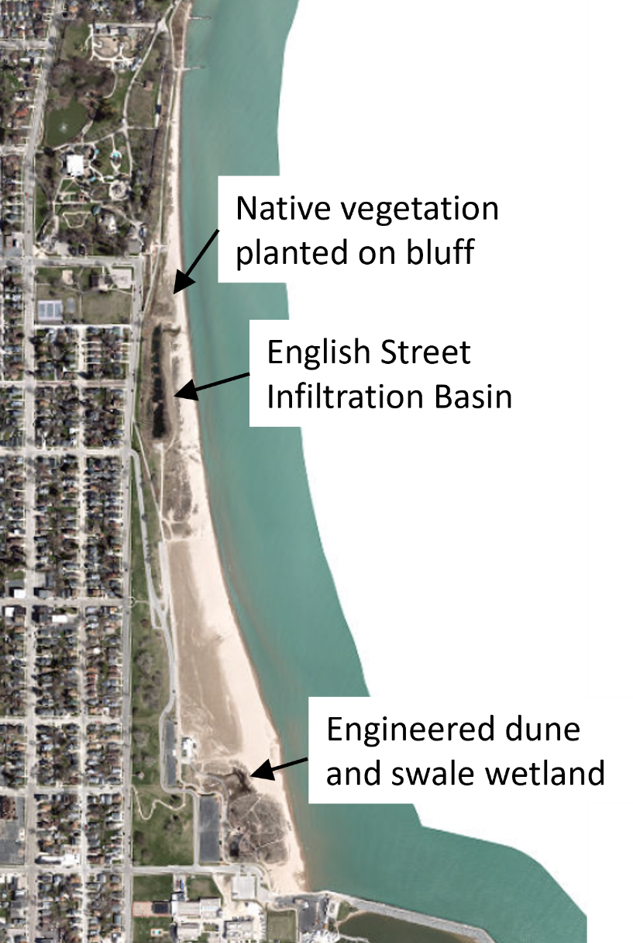
Our Engineering Field Site – North Beach
Recently, coastal engineering has been used to work with nature through the implementation of green infrastructure along Racine’s coast to manage stormwater, improve water quality and mitigate erosion. Green infrastructure keeps Racine’s beaches safe, accessible and resilient. The techniques at North Beach include the development of innovative water quality monitoring processes, studies on improved beach grooming techniques, dune restoration as habitat and natural infrastructure, and the implementation of green infrastructure to absorb and treat stormwater runoff from upstream watersheds.
Three examples of green infrastructure practices implemented at North Beach include:
- Native vegetation planted on bluff
- English Street infiltration basins
- An engineered dune and swale wetland
Map Data: Sources: Esri, HERE, Garmin, Intermap, increment P Corp., GEBCO, USGS, FAO, NPS, NRCAN, GeoBase, IGN, Kadaster NL, Ordnance Survey, Esri Japan, METI, Esri China (Hong Kong), (c) OpenStreetMap contributors, and the GIS User Community

1) Native vegetation planted on bluff
When the Lake Michigan Pathway was constructed in 2006, the bluff was planted with a variety of native vegetation species. The vegetation’s roots hold the soil in the bluff in place against erosion. The soil pore spaces created by the roots enhance water infiltration and reduce runoff to the beach.
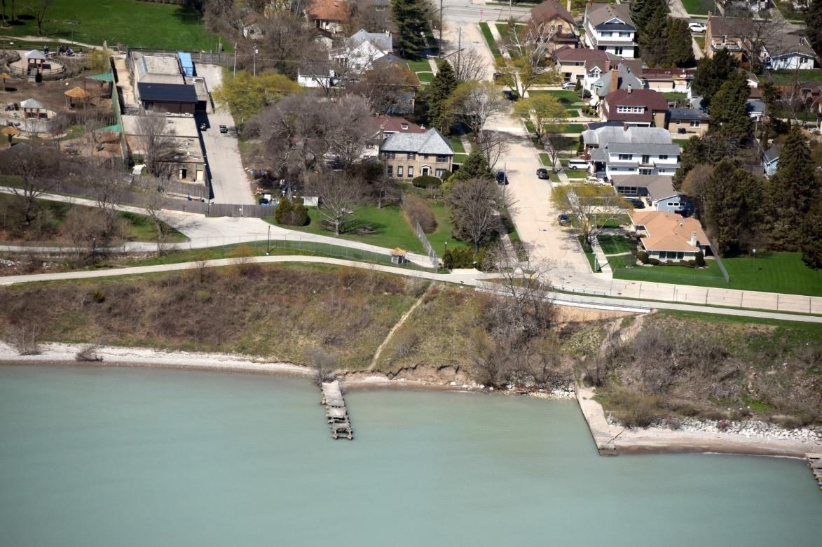
Image source: Capt. Dennis Carr, Wisconsin Wing, Civil Air Patrol

2) English Street infiltration basin/constructed wetland
The English Street outfall used to discharge untreated stormwater directly to the beach. This untreated stormwater often was high in harmful bacteria (E. coli) and had a negative impact on water quality at the beach. In 2001, this outfall was reconstructed with the goal to remove pollutants from the runoff before it gets to the beach.
The system consists of:
- An underground solid particle treatment system (Vorceptor), which helps settle out large particles in the runoff.
- A series of constructed wetland cells which slowly pass water through, allowing further particle settling, filtration of the water by the vegetation, and infiltration of water to the groundwater.
The water that flows through this system is then discharged into Lake Michigan at an outfall. This treatment system has been very successful in improving water quality at North Beach (among other efforts).
There is also an overflow outfall for large storm events which produce too much runoff for the English Street infiltration system to effectively treat.
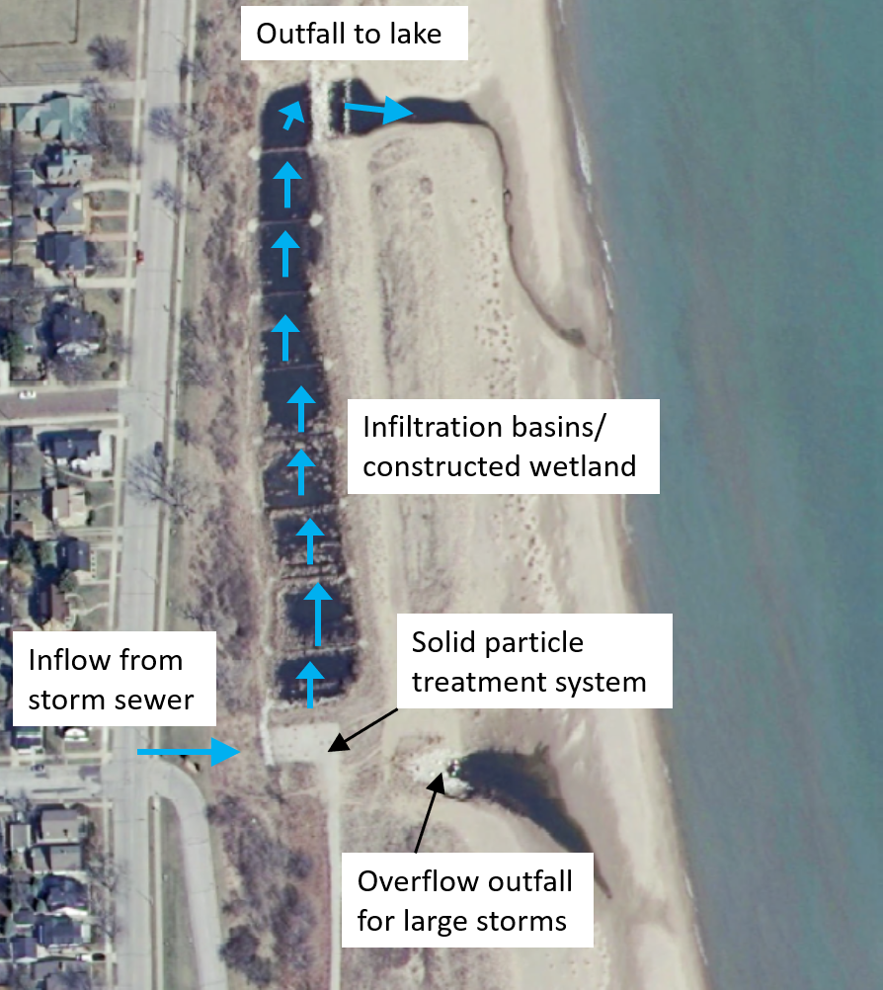
Map Data: Southeastern Wisconsin Regional Planning Commission

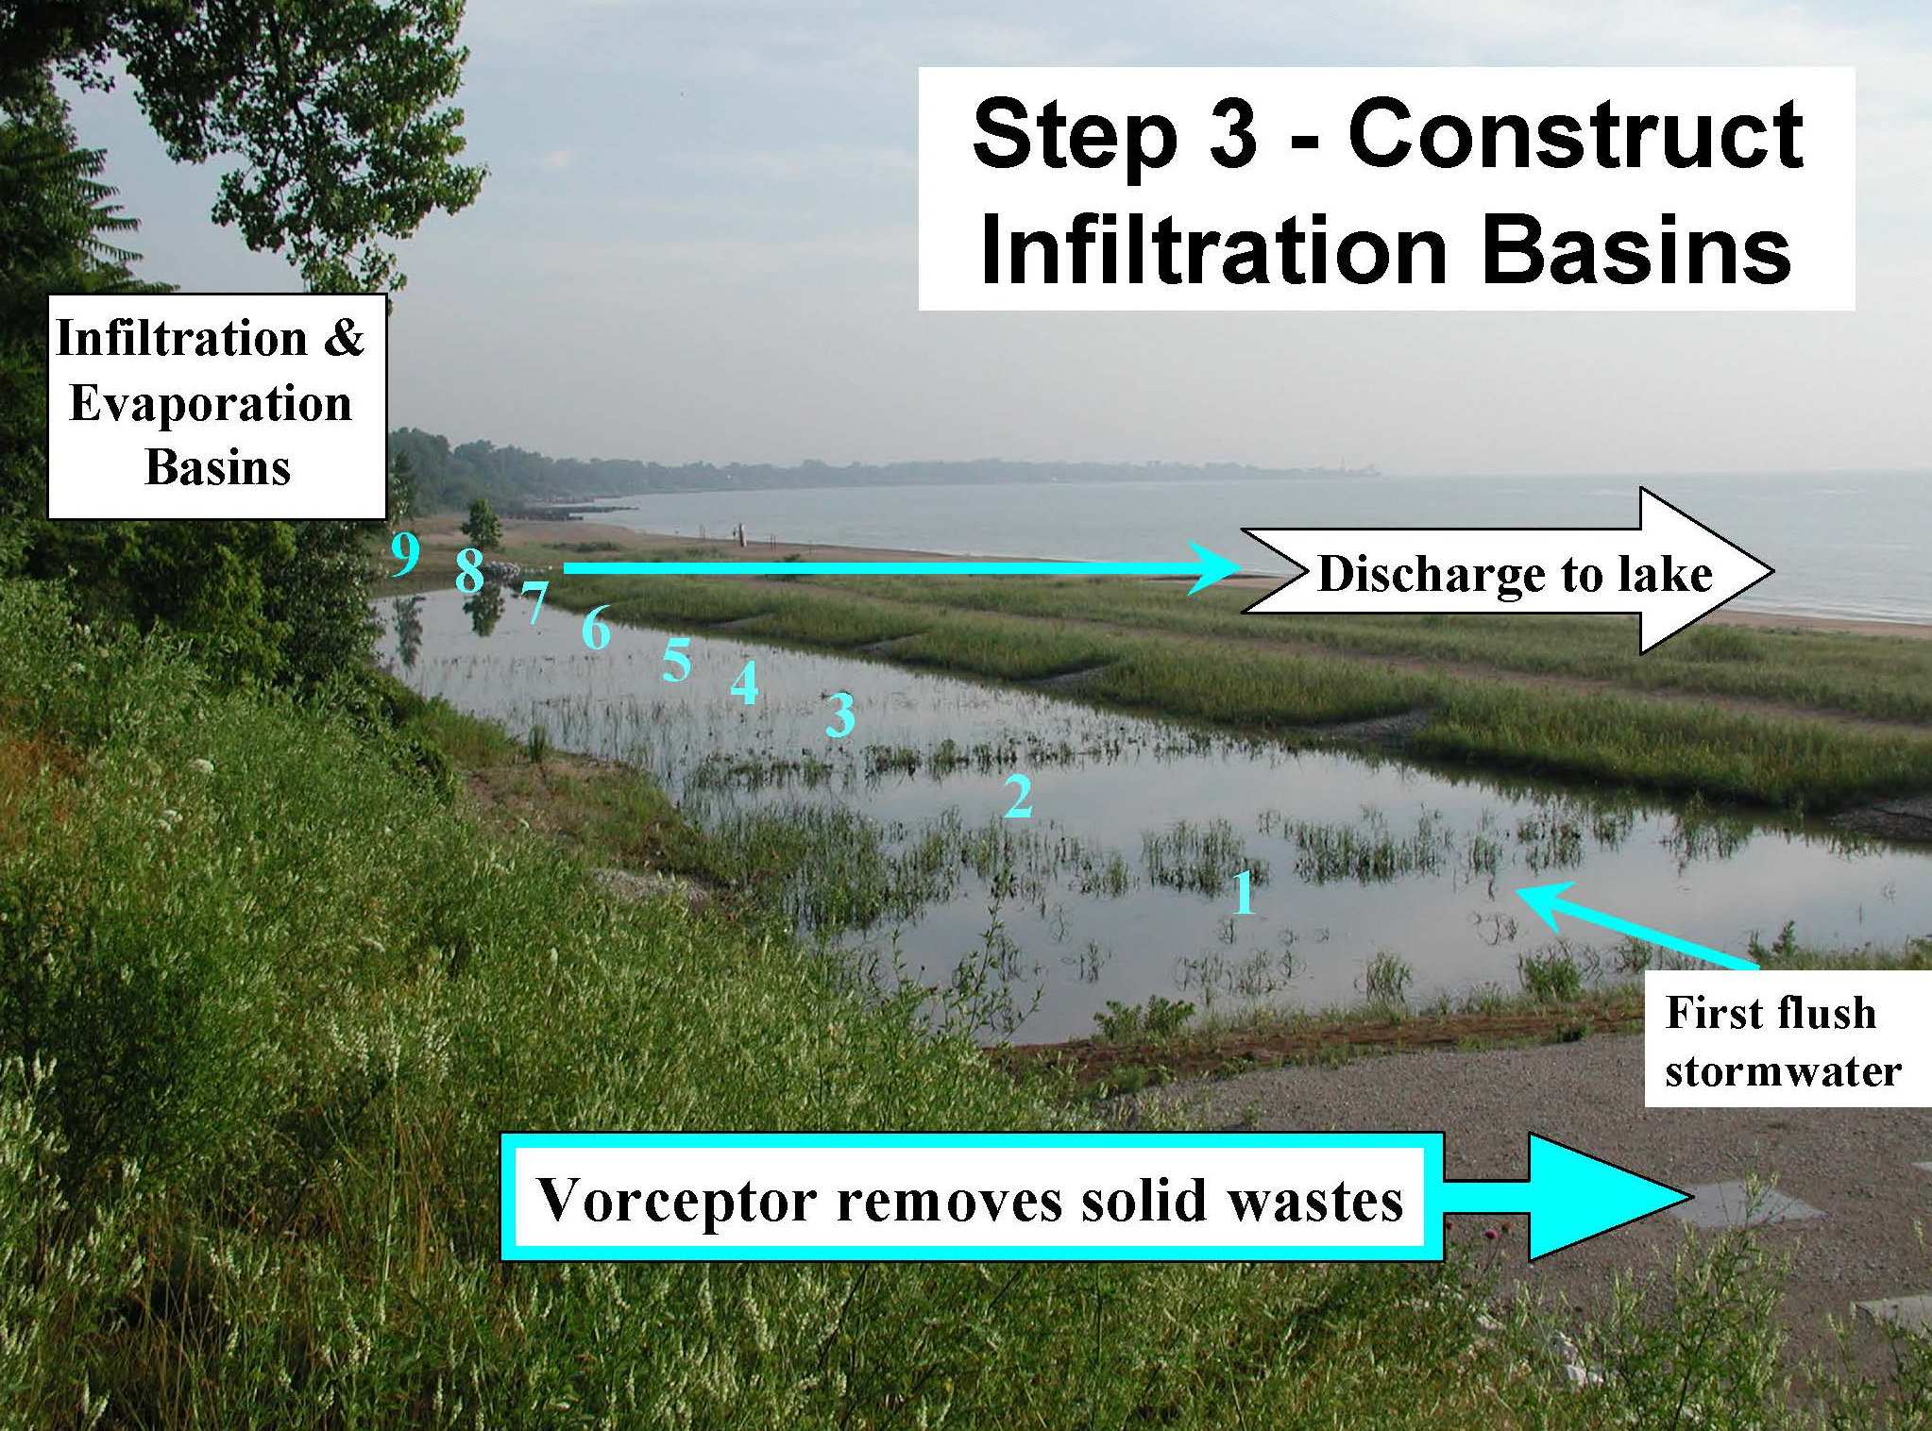
Image source: Julie Kinzelman, City of Racine
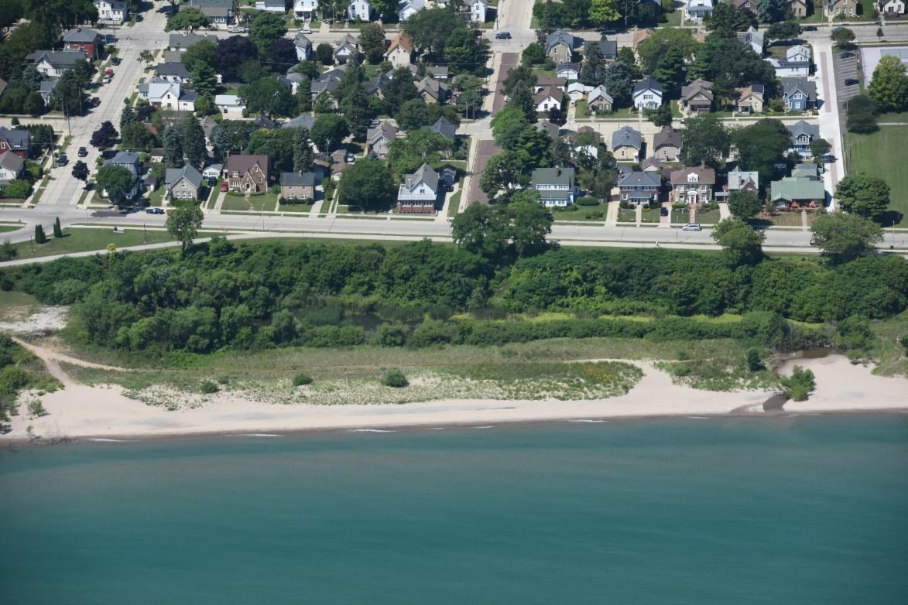
The English Street infiltration basin/constructed wetland can be seen from the air:
Image source: Capt. Dennis Carr, Wisconsin Wing, Civil Air Patrol

3) Engineered dune and swale wetland
An engineered wetland was installed from 2007 to 2009 to capture and infiltrate runoff from the main North Beach parking lot and other nearby impervious surfaces, such as boardwalks. This engineered wetland consists of dunes with wetlands between them, known as swales. Capturing and infiltrating runoff in this wetland reduces the amount of runoff that reaches the beach.
The engineered dune and swale wetland system can be seen capturing runoff from the main North Beach parking lot.
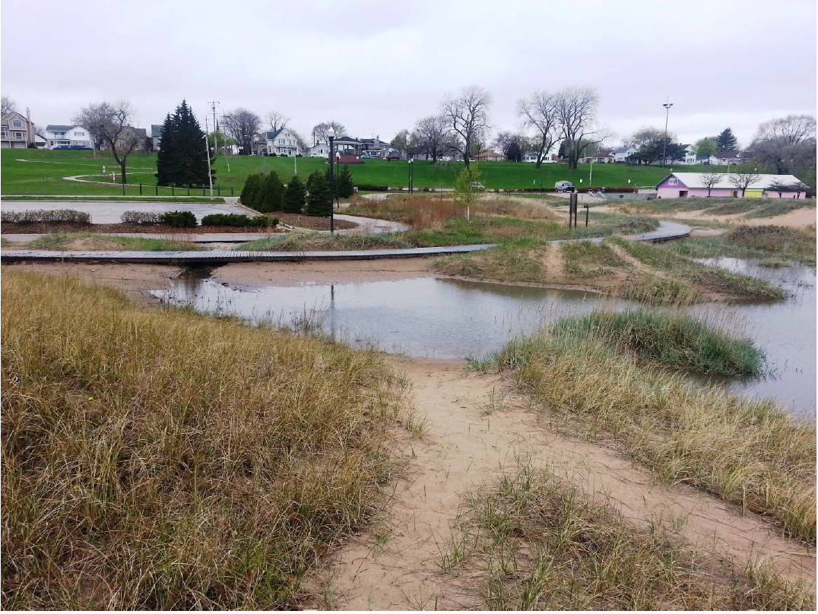
Image source: City of Racine

A flow pathway from the main North Beach parking lot to the engineered dune and swale wetland can be seen in this aerial photograph.
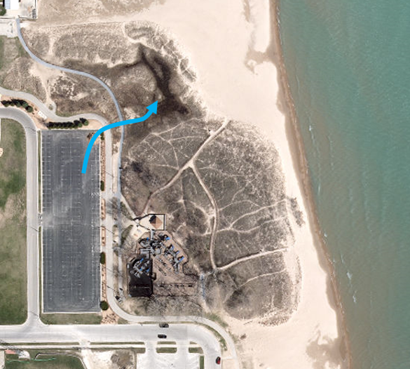
Map Data: Sources: Esri, HERE, Garmin, Intermap, increment P Corp., GEBCO, USGS, FAO, NPS, NRCAN, GeoBase, IGN, Kadaster NL, Ordnance Survey, Esri Japan, METI, Esri China (Hong Kong), (c) OpenStreetMap contributors, and the GIS User Community

