Name: Class Period: Date:

CALCULATING ROOF RUNOFF AMOUNTS — ANSWER KEY

Step 1: Calculate area of the roof.
- Examine the shape and size of the roof illustrated on the next page.
- The formula needed to calculate the roof area is:
  - Area of a rectangle = length x width
- Repeat calculation for each roof segment and add together.

Step 2: Multiply by the conversion factor (0.56) to convert inch of rain that fell on the roof to gallons of rain that fell on the roof.

Step 3: Multiply by annual rainfall.

Example
Building is 30 feet wide and 50 feet long. The city of Racine gets 36 inches of rain per year.
- Area of roof is 30 feet x 50 feet = 1500 square feet
- 1500 square feet x 0.56 gallons/inch of rain per square foot = 840 gallons/inch of rain
- 840 gallons/inch of rain x 36 inches of annual rainfall = 30,240 gallons of rain per year from this roof
Answer: 30,240 gallons of rain per year from this roof.

Your Turn

The school building and its roof is shaped like the letter T. The top portion of the T is 20 feet wide by 50 feet long. The vertical portion of the T is 30 feet wide by 60 feet long. This school has an average of 20 inches of rain falling on it each year. Using a conversion factor of 0.56 gallons/inch of rain per square foot of roof, calculate how many gallons of rain per year could be collected from this school roof. Show your work.
My calculations for the number of gallons of rain per year that could be collected from this school roof.
My calculations for the area of the roof.

Extension Idea
You can find the annual rainfall for your county using the NOAA Climate at a Glance tool. Select Wisconsin as the state and click “plot.” Hover over your county and the mean annual rainfall amount will be displayed below the map (number next to “mean”). A table of precipitation statistics for each county is also given below the map (not shown). Statistics besides “mean” are precipitation statistics for the year given in the “year” selection box.
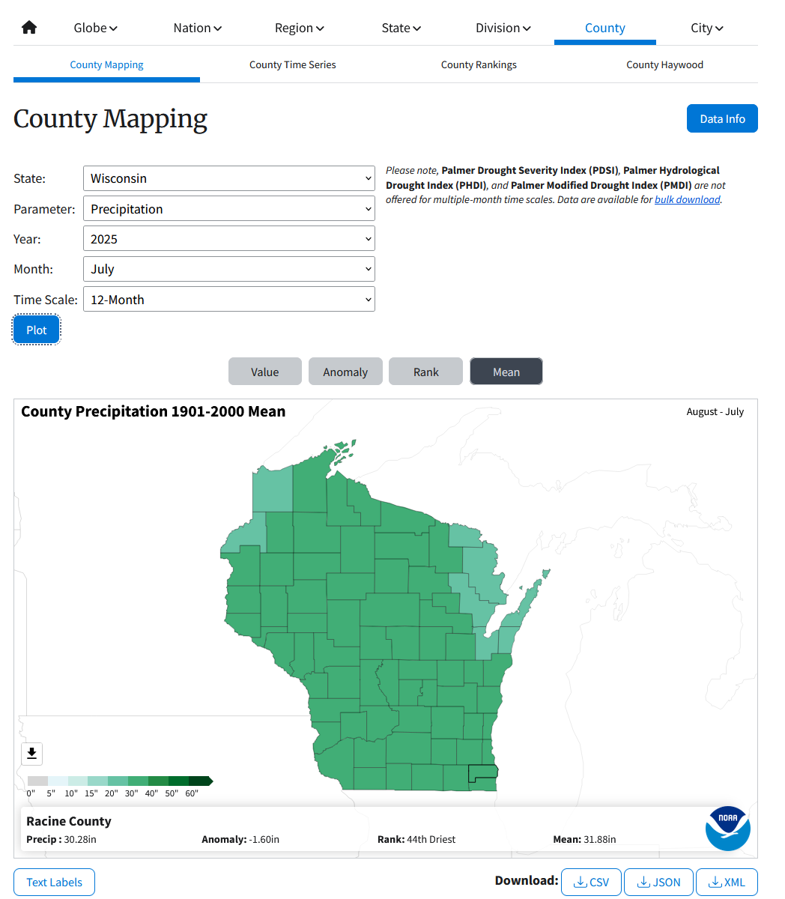

SOLUTION ONE FOR CALCULATING AREA OF THE ROOF
1. Area of the horizontal “top of T” part of the roof rectangle:
20 feet wide x 50 feet long = 1000 square feet
2. Area of the “vertical bar of T” part of the roof rectangle that hasn’t already been accounted for:
30 feet wide x 40 feet long = 1200 square feet
3. Total area of the roof = 1000 square feet + 1200 square feet = 2200 square feet

ALTERNATE WAY FOR CALCULATING AREA OF THE ROOF
1. Area of the horizontal “top of T” part of the roof rectangle:
20 feet wide x 50 feet long = 1000 square feet
2. Area of the “vertical bar of T” part of the roof rectangle:
30 feet wide x 60 feet long = 1800 square feet
3. Area of the two portions of the T roof = 1000 square feet + 1800 square feet = 2800 square feet
4. Area of overlap (counted twice) = 30 feet wide x 20 feet long = 600 square feet
5. Total area of roof = 2800 square feet - 600 square feet = 2200 square feet

CALCULATING RUNOFF AMOUNT
2200 square feet of roof x 20 inches rain/year x 0.56 gallons/inch per sq foot of roof =
24,640 gallons

MISINTERPRETATION OF ROOF SIZE
If students answer 2800 square feet for the roof size, then they have accounted for a portion of the roof twice (see diagram below). With this incorrect roof size, they are likely to overestimate the number of gallons of runoff.
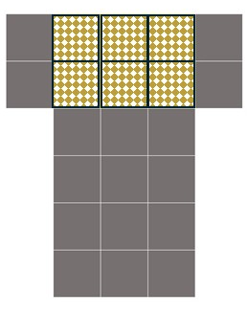
2800 square feet of roof x 20 inches rain/year x 0.56 gallons/inch per sq foot of roof = 31,360 gallons

