Name: Class Period: Date:

CALCULATING RAIN GARDEN SIZE NEEDED FOR
KIDS COVE PARKING LOT

Step 1: Estimate the length and width of the Kids Cove parking lot (the impervious area) by using the map and scale below.
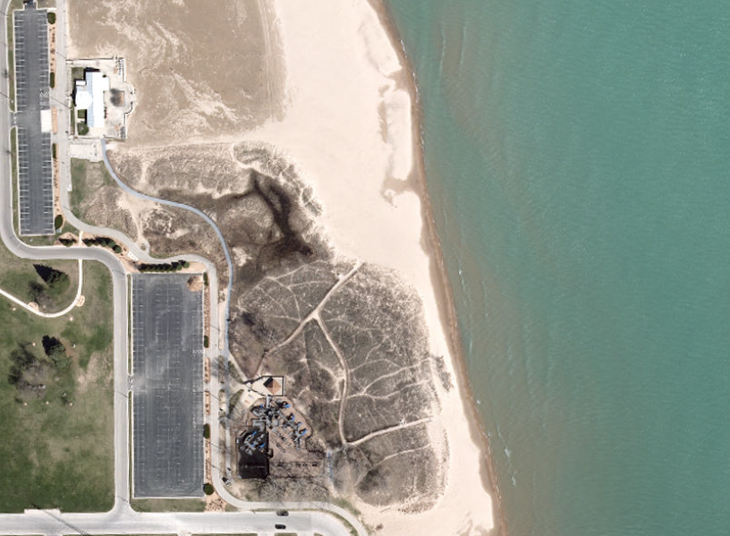

0
100’
200’
400’
Scale: 1”=200’
50’

Image source: Southeastern Wisconsin Regional Planning Commission

Step 2: Calculate the area of the Kids Cove parking lot.
- The Kids Cove parking lot is the one at the south end of the picture, east of the grassy green area, and west of the playground.
- The formula needed to calculate the area of a rectangle is:
  - Area of a rectangle = length x width

Step 3: Use Sizing Factor.
- Use the table to determine the sizing factor for the soil type you think is at North Beach.
Rain gardens are typically 13 to 35 percent the size of the impervious surface generating the runoff entering the garden. Engineers use a number called a sizing factor to figure out how big to make a rain garden in different soils. The more a soil can infiltrate water, the smaller the sizing factor.
 | Soil Type
 | Sandy | Silty | Clayey
Sizing Factor | 0.13 | 0.3 | 0.35
Data source: Wisconsin Department of Natural Resources

Step 4: Calculate size of rain garden needed.
- Multiply the area of the parking lot by your chosen sizing factor to calculate the size of the rain garden needed in square feet.

Your Turn
Calculate the area of the Kids Cove parking lot. Using your chosen sizing factor, calculate the rain garden size needed at the Kids Cove parking lot. Show your work.

Estimated length of parking lot _________feet.
My calculations for the rain garden size needed for the Kids Cove parking lot.
The sizing factor I think I should use for North Beach is: _________
The reason I think I should use this sizing factor is because
My calculations for the area of the parking lot.
Estimated width of parking lot _______feet.

Wisconsin Department of Natural Resources – Rain Garden Manual https://dnr.wi.gov/topic/Stormwater/documents/RainGardenManual.pdf

