Name: Class Period: Date:

GRAPHIC ORGANIZER — ANSWER KEY

Step 1: Review the “Protecting the Coast – A Top-Down Approach” illustration.

Protecting the coast - A Top-Down Approach

Step 2: Take notes.
- Take notes within the table using information provided during the “Coastal Engineering at North Beach” slideshow. Draw any supporting images on the last page of this graphic organizer.
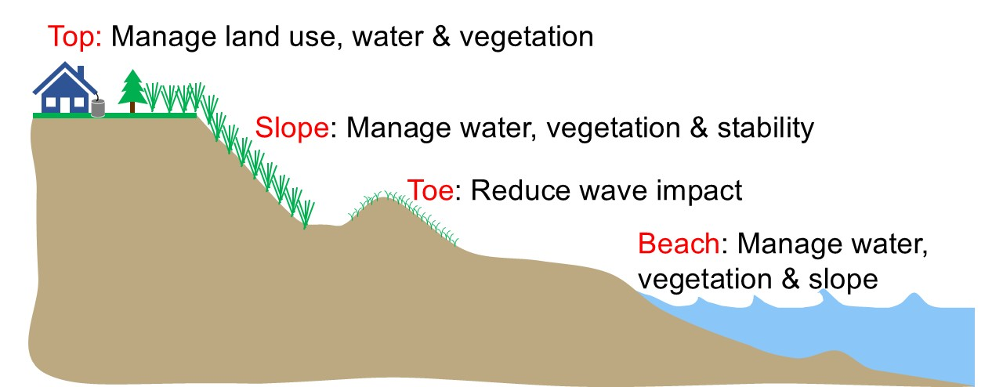
Image source: Adam Bechle, Wisconsin Sea Grant

 | Solution 1 | Solution 2 | Solution 3 | Solution 4
What (Identify the problem) | Erosion | Beach Closures | Sand Burying Boardwalks | Washouts
Where (Identify the location -- top, slope, toe, beach) | Mostly Toe and Beach  Possibly top and slope if erosion progresses far enough | Beach | Toe and Beach  Possibly top and swales within the slope region (Note: There are boardwalks through the dune in front of Kids Cove. There are many trails in the dune but they are cordoned off to prohibit access – keeping a straighter path on boardwalks.) | Slope and Beach areas  Especially near parking lots.

 | Solution 1 | Solution 2 | Solution 3 | Solution 4
Causes (Identify why this is happening) | Waves and currents cause sediment transport.  The top and slope may be eroded due to human impact (e.g., climbing on dunes, poor vegetation management.) | E. coli, algal blooms, sea gull feces, litter, and contaminated runoff create health hazards. | Wind picks up sand that is not held down. | Water runs off from the back beach area.
Solutions (Describe the engineered solutions) | Gray Infrastructure  - Revetment  - jetty  - breakwater  - seawall  Green Infrastructure  Native vegetation planted on bluff to protect dunes | Beach Grooming and Beach Slope Maintenance  Green Infrastructure  English Street infiltration basin | Green Infrastructure  - Native vegetation planted on bluff  Engineered dune and swale wetland | Green Infrastructure  Engineered dune and swale wetland

 | Solution 1 | Solution 2 | Solution 3 | Solution 4
Effects (Describe type of water movement the solution tries to impact) | Waves  Currents  Water levels  Runoff  Infiltration | Waves  Runoff  Evaporation | Runoff  Infiltration  Transpiration | Runoff  Infiltration  Transpiration
Obstacles (Describe some of the challenges) | Some areas of coastline “gain” sediment while other areas “lose” sediment—need to balance. | Equipment costs.  Can’t easily be done when people are on the beach. | Need to position appropriately to intercept prevailing wind. | Need to size appropriately (runoff calculations).

My Additional Notes and Drawings

