Name: Class Period: Date:

GRAPHIC ORGANIZER

Step 1: Review the “Protecting the Coast – A Top-Down Approach” illustration.

Protecting the coast - A Top-Down Approach

Step 2: Take notes.
- Take notes within the table using information provided during the “Coastal Engineering at North Beach” slideshow. Draw any supporting images on the last page of this graphic organizer.
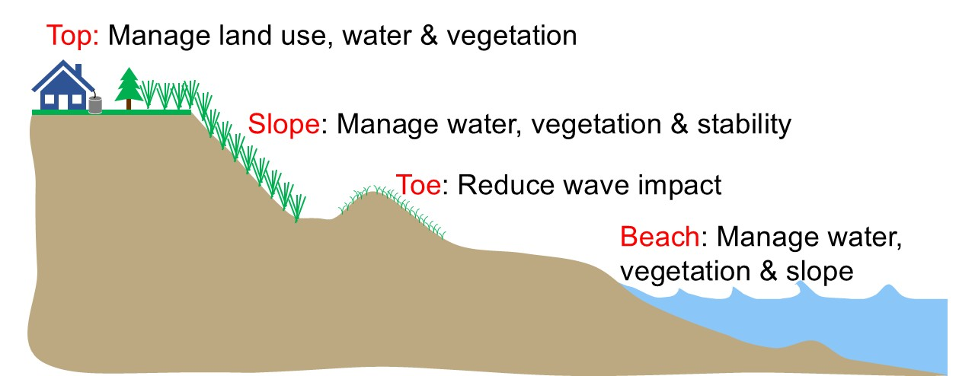
Image source: Adam Bechle, Wisconsin Sea Grant
 | Solution 1 | Solution 2 | Solution 3 | Solution 4
What (Identify the problem)
Where (Identify the location -- top, slope, toe, beach)

 | Solution 1 | Solution 2 | Solution 3 | Solution 4
Causes (Identify why this is happening)
Solutions (Describe the engineered solutions)

 | Solution 1 | Solution 2 | Solution 3 | Solution 4
Effects (Describe type of water movement the solution tries to impact)
Obstacles (Describe some of the challenges)

My Additional Notes and Drawings

