Coastal Engineering
People, Places & Practices




Teacher’s Guide

A Place-Based Curriculum for the Great Lakes
and Racine, Wisconsin

Wisconsin Sea Grant, UW-Aquatic Sciences Center | October 2025
Developed and written by
ADAM BECHLE, coastal engineer, Wisconsin Sea Grant
GINNY CARLTON, education outreach specialist, Wisconsin Sea Grant
ANNE MOSER, senior special librarian and education coordinator, Wisconsin Water Library and Wisconsin Sea Grant
Produced by
ELIZABETH WHITE, editor, Wisconsin Sea Grant
BONNIE WILLISON, videographer, Wisconsin Sea Grant

This curriculum was prepared under award number NA21NOS4290005 from the Great Lakes Bay Watershed Education and Training (B-WET) program of the National Oceanic and Atmospheric Administration (NOAA), U.S. Department of Commerce. The statements, findings, conclusions and recommendations are those of the author(s) and do not necessarily reflect the views of NOAA or the U.S. Department of Commerce.

Website with all lesson plans and supporting materials
go.wisc.edu/coastal-engineering
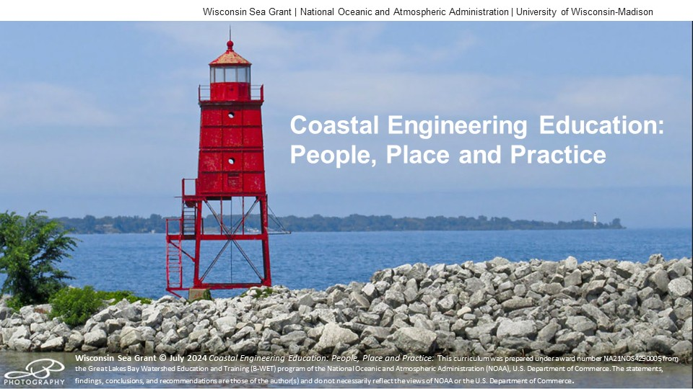

Coastal Engineering: People, Places and Practices
Coastal Engineering
People, Places & Practices

Teacher’s Guide

CONTENTS
Summary 3
Lesson Outlines 7
ONE: Introduction to Coastal Engineering 7
TWO: Coastal Features and Processes of the Great Lakes 8
THREE: Coastal Engineering Structures- Protecting the Shoreline 9
FOUR: Stormwater Management 10
FIVE: Introduction to Green Infrastructure 11
SIX: Coastal Engineering at North Beach 12
Files Needed by Lesson 13
Next Generation Science Standards 16
Wisconsin Model Academic Standards 17
Great Lakes Literacy Principles 21
Website with all lesson plans and supporting materials
go.wisc.edu/coastal-engineering

SUMMARY

BRIEF DESCRIPTION
This curriculum project was originally designed to connect middle school students and staff from Jerstad-Agerholm School in Racine, Wisconsin, to their Lake Michigan watershed by exploring coastal engineering concepts through meaningful watershed educational experiences.
Additionally, it was important for us to include career pathways that introduce students to a variety of coastal engineering, green infrastructure, and healthy beach management careers—hence the people portion of the project.
The curriculum topics of the scientific method versus the engineering design process, coastal features and processes, coastal engineered structures (gray infrastructure), stormwater management, and green infrastructure are broadly applicable to other locations within the Great Lakes basin.

KEYWORDS
middle school science, Wisconsin Sea Grant, coastal engineering, green infrastructure,
North Beach, Wisconsin

TEACHING AREAS
Science | Engineering | Environmental Literacy & Sustainability | Geography | Mathematics | Language Arts

GRADES
6-8

UNIT PLAN
Lesson 1 Introduction to Coastal Engineering Middle school students are introduced to the field of coastal engineering and start to become familiar with the engineering design process, a key method coastal engineers use to address problems at our shorelines. Current coastal engineering issues include erosion, loss of habitat, flooding, property damage, threats to human life and wellbeing, and more. The students are also oriented to the location of the field site on the shore of Lake Michigan at North Beach. The geographic positions of the school, Lake Michigan, and Racine Harbor serve as reference points as students build, or enhance, their personal conceptual geographic map of natural and constructed features within the city of Racine.
Lesson 2 Coastal Features and Processes of the Great Lakes Learning the basics of coastal engineering and the features of the Great Lakes enables students to understand what they see at the North Beach field site. In the 19th and 20th centuries, the transformation of the Lake Michigan shoreline resulted in deeper harbors and safer transportation infrastructure, including changes at the Racine Harbor. Human activity, coordinated by coastal engineering practices, has helped create the North Beach we see today. By understanding this change in coastal configuration, the students are introduced to the intended and unintended consequences of engineering. In this lesson, students are exposed to a variety of coastal features found around the Great Lakes and those specific to North Beach. In addition, they are exposed to the coastal processes (one of which is changing water levels) that continue to shape these features.
It’s important for the students to understand that scientific investigations often answer questions such as how one thing is related to another. For example, it is important for students to understand that water levels change not only from year to year but also from season to season. Additionally, water doesn’t only increase and decrease in depth, it also moves from one location to another. This lesson will highlight some of the ways water moves and the forces that cause it to move.
Lesson 3 Coastal Engineering Structures Protecting the Shoreline Students are introduced to seven common solutions coastal engineers use to protect the shoreline from flooding, erosion, poor water quality and beach closures. These common engineered solutions include structures such as revetments and breakwaters and practices such as beach nourishment or green infrastructure. Lesson three specifically focuses on the engineering structures built at North Beach: revetment, breakwater, jetty and seawall. In addition, the students expand their spatial learning with the introduction of Google Earth as a mapping tool.
Lesson 4 Stormwater Management Students are reintroduced to the hydrologic cycle -- the natural path water takes due to gravitational forces, beginning with precipitation, then infiltration or runoff, and finally via flow through rivers and wetlands as the water travels to Lake Michigan. Students are introduced to ways in which humans have altered the natural path of water flow (e.g., via installation of impermeable surfaces). Finally, students are exposed to the consequences of this interference by considering the impacts of stormwater management.
Because coastal waters are connected to surface water and groundwater via the hydrologic (water) cycle, students need to understand how engineers manage water movement within the entire watershed in addition to understanding how engineers use coastal structures to manage the movement of water and sediments along the coast.
Lesson 5 Introduction to Green Infrastructure Students begin to synthesize the previous four lessons. They consider the amount of rain recorded in the city of Racine, calculate the amount of that rain that runs off roofs, and learn about natural and manmade structures, especially green infrastructure, that manage that runoff.
Lesson 6 Coastal Engineering at North Beach Students prepare for their field trip by exploring the coastal engineering approaches found at North Beach where coastal engineers have used both gray infrastructure and green infrastructure to protect the coast. The students recall the coastal processes and features that influence the shoreline’s shape and how coastal engineers have used infrastructure approaches to control flooding, mitigate erosion and improve water quality at North Beach, Racine, Wisconsin.

BUILD YOUR OWN UNIT PLAN

ACTIVITY | TIME NEEDED
Lesson 1: Ideal Apple Pie a la Mode Eating Utensil | 5 minutes
Lesson 1: What is Engineering? video | 5 minutes
Lesson 1: The Engineering Design Process slideshow | 5 minutes
Lesson 1: The Engineering Design Process for a Floatable Object | 15 minutes
Lesson 1: Racine Harbor Through Time slideshow | 10 minutes
Lesson 1: My Map of the City of Racine | 10 minutes
Lesson 1: Return to Racine Harbor slideshow | 5 minutes
Lesson 1: Science and Engineering Similarities and Differences | 10 minutes
Lesson 1: Exit Slip | 5 minutes

Lesson 2: Lake Michigan Water Levels | 10 minutes
Lesson 2: Water and Sediment on the Lake Michigan Shoreline (Wave Tank) | 25 minutes
Lesson 2: Coastal Terms Drag and Drop | 5 minutes
Lesson 2: Four Coastal Processes slideshow | 5 minutes
Lesson 2: Historic Beach Width Measurement | 15 minutes

Lesson 3: Using the EDP to Design a Coastal Structure | 25 minutes
Lesson 3: Four Coastal Structures Found at North Beach slideshow | 5 minutes
Lesson 3: Map it on Google Earth | 15 minutes
Lesson 3: Exit Slip | 5 minutes

Lesson 4: What Is Stormwater? How Does It Fit with the Hydrologic Cycle? | 5 minutes
Lesson 4: The Hydrologic Cycle slideshow | 5 minutes
Lesson 4: Soil Infiltration and Percolation Test | 30 minutes
Lesson 4: Stormwater Runoff Demonstration—Crumpled Paper Watershed | 10 minutes
Lesson 4: Flooding at North Beach slideshow | 5 minutes
Lesson 4: Our Racine Today slideshow | 5 minutes
Lesson 4: Exit Slip | 5 minutes

BUILD YOUR OWN UNIT PLAN (Continued)

ACTIVITY | TIME NEEDED
Lesson 5: Racine Water Trivia | 5 minutes
Lesson 5: Calculating Runoff Amounts off a Roof | 10 minutes
Lesson 5: How Wetlands Manage Runoff video | 5 minutes
Lesson 5: Just Breathe Transpiration Rate Demonstration | 10 minutes
Lesson 5: Introduction to Green Infrastructure slideshow | 5 minutes
Lesson 5: Calculating Rain Garden Size | 10 minutes
Lesson 5 Exit Slip | 5 minutes

Lesson 6: Public Service Announcement for North Beach | 5 minutes
Lesson 6: Coastal Engineering at North Beach – Part 1 slideshow | 10 minutes
Lesson 6: Coastal Engineering at North Beach – Part 2 slideshow | 10 minutes
Lesson 6: Calculating Runoff for Kids Cove Parking Lot | 5 minutes
Lesson 6: Calculating Rain Garden Size for Kids Cove Parking Lot | 5 minutes
Lesson 6: Green Infrastructure at North Beach slideshow | 15 minutes
Lesson 6: Racine Beaches Quest | 15 minutes
Lesson 6: Exit Slip | 5 minutes

LESSON OUTLINES

LESSON ONE: INTRODUCTION TO COASTAL ENGINEERING
Full Day One Lesson Plan

LESSON CONCEPTS
- Science and engineering are related in that they incorporate similar steps. However, the scientific method is a linear process designed to investigate what is, while the engineering design process is iterative and designed to solve an identified problem.
- Maps serve as two-dimensional representations of features on a landscape.
- A map’s key and scale are important to interpreting how a map represents actual features found on a landscape.

BACKGROUND INFORMATION FOR EDUCATOR
Background Information Lesson 1: Introduction to Coastal Engineering - Background

LEARNING OBJECTIVES
Students can
- Identify the steps of the engineering design process.
- Explain the similarities and differences between science and engineering.
- Perform tasks foundational to creating a map (e.g., estimate the distance between specified locations and determine the spatial orientation between two locations) by completing a distance and relative position chart.
- Draw a map illustrating the relative positions of the school, Lake Michigan, and a feature of the student’s choice.
- Iteratively use the engineering design process to create a sequence of clay objects with the goal of designing an object that floats.
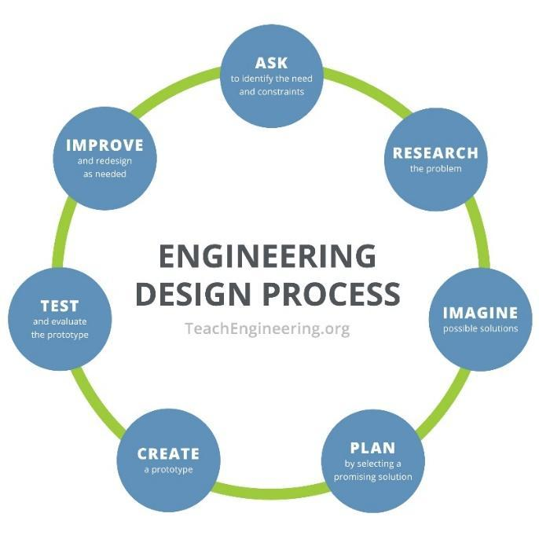

LESSON TWO: COASTAL FEATURES AND PROCESSES
Full Day Two Lesson Plan

LESSON CONCEPTS
- Water’s movements — both on the land and underground — cause weathering and erosion, which change the land’s surface features.
- The abundance of liquid water on Earth’s surface and its unique combination of physical and chemical properties are central to the planet’s dynamics.
- A variety of hazards result from natural processes.
- Humans cannot eliminate natural hazards but can take steps to reduce their impacts.
- Human activities can contribute to the frequency and intensity of some natural hazards.
- The sustainability of human societies and the biodiversity that supports them require responsible management of natural resources. Scientists and engineers can make major contributions — for example, by developing technologies that produce less pollution and waste and that preclude ecosystem degradation.

BACKGROUND INFORMATION FOR EDUCATOR
Background Information Lesson 2 Background: The Coastal Features and Processes of the Great Lakes - Background
Background Slideshow Coastal Processes Demonstration - The Wave Tank

LEARNING OBJECTIVES
Students can
- Label a coastal diagram when given a set of terms — thereby demonstrating an understanding of common terms used to describe coastal ecosystems.
- Describe components of the water budget/water cycle that influence lake levels.
- Analyze a graph to determine the highest and lowest water levels (to the nearest foot IGLD 1985) ever recorded between 1920 and 2021 for Lake Michigan. Then use these numbers to calculate the magnitude of the change in water level.
- Explain the four processes (changes in lake level due to water cycle, water movement via waves, water movement via currents, and sediment transport) that shape the coast.
- Describe what happens to a beach that is exposed to the force of waves or currents.
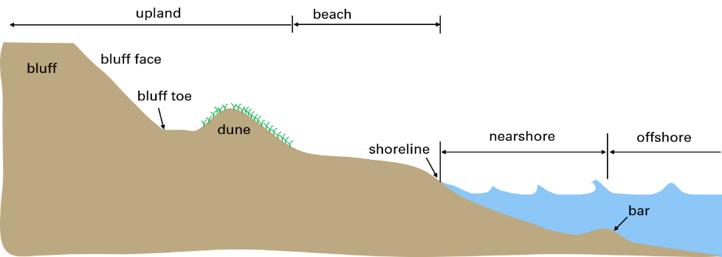

LESSON THREE: COASTAL ENGINEERING STRUCTURES
Full Day Three Lesson Plan

LESSON CONCEPTS

Water’s movements — both on the land and underground — cause weathering and erosion, which change the land’s surface features.

A variety of hazards results from natural processes.

Humans cannot eliminate natural hazards but can take steps to reduce their impacts.

Human activities can contribute to the frequency and intensity of some natural hazards.

The sustainability of human societies and the biodiversity that supports them require responsible management of natural resources. Scientists and engineers can make major contributions — for example, by developing technologies that produce less pollution and waste and that preclude ecosystem degradation.

BACKGROUND INFORMATION FOR EDUCATOR

Background Information Lesson 3: Coastal Engineering Structures – Protecting the Shoreline Background

Background Slideshow Wave Tank Demonstration

Background Support Materials Aerial Photographs

LEARNING OBJECTIVES
Students can
- Name at least three design considerations engineers must take into account when planning to install a coastal engineering structure that is designed to reduce or mitigate a natural coastal hazard.
- Generalize the benefits (e.g., flood control, erosion management, and beach stabilization) and challenges (e.g., changes to sediment transport processes that can have impacts to neighboring properties, cost, working in water of varying depths, available space) of designing and installing coastal engineering structures.
- Complete a Google Earth project that maps specified natural and man-made features associated with the area containing the city of Racine and North Beach.
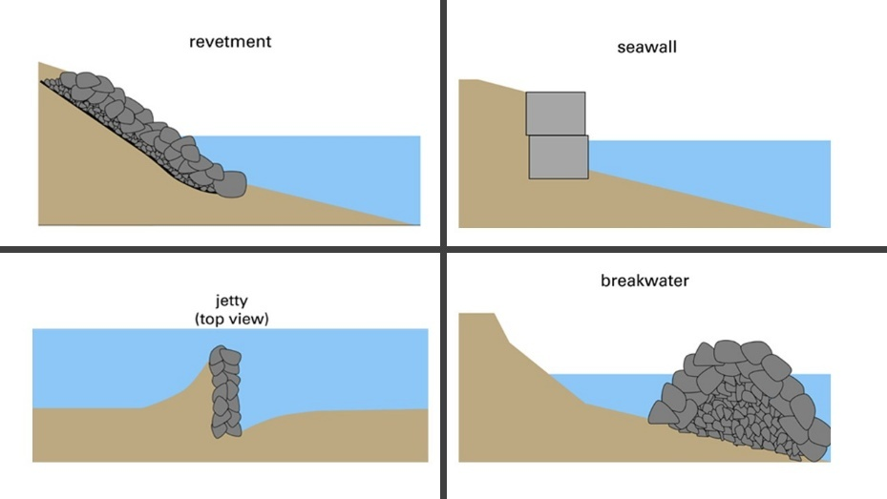

LESSON FOUR: STORMWATER MANAGEMENT
Full Day Four Lesson Plan

LESSON CONCEPTS
- Water’s movements — both on the land and underground — cause weathering and erosion, which change the land’s surface features.
- The sustainability of human societies and the biodiversity that supports them require responsible management of natural resources. Scientists and engineers can make major contributions — for example, by developing technologies that produce less pollution and waste and that preclude ecosystem degradation.

BACKGROUND INFORMATION FOR EDUCATOR
Background Information Lesson 4: Stormwater Management-Background

LEARNING OBJECTIVES
Students can
- Identify at least two human actions or infrastructure elements that influence how water moves across the landscape.
- Generalize the natural path of water movement beginning with precipitation falling within the city of Racine and ending with water entering Lake Michigan.
- Generalize the path of water movement through storm water management infrastructure that is designed to move water from where it falls within the city of Racine to where it enters Lake Michigan.
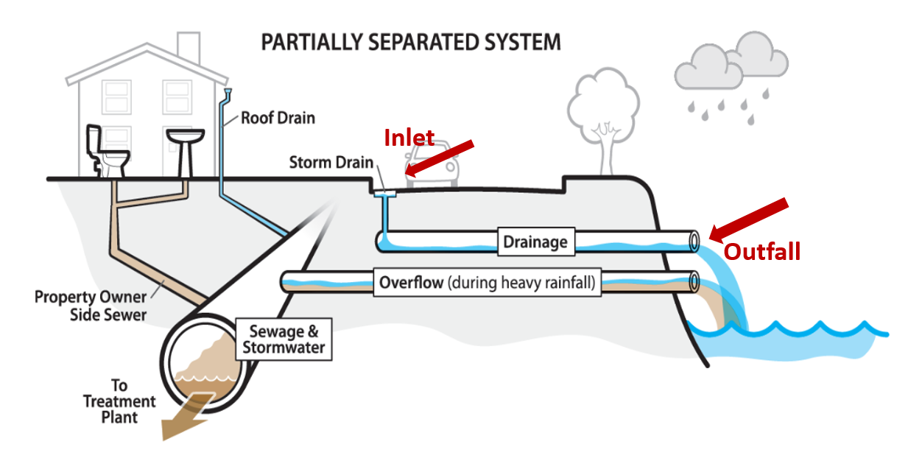
- Make predictions related to how water will percolate through soil, and document whether their observations support their predictions.
Image: City of Seattle: https://www.seattle.gov/Documents/Departments/SPU/CRPDWWOverview10122016.pdf

LESSON FIVE: INTRODUCTION TO GREEN INFRASTRUCTURE
Full Day Five Lesson Plan

LESSON CONCEPTS
- The sustainability of human societies and the biodiversity that supports them require responsible management of natural resources. Scientists and engineers can make major contributions — for example, by developing technologies that produce less pollution and waste and that preclude ecosystem degradation.

BACKGROUND INFORMATION FOR EDUCATOR
Background Information Lesson 5: Introduction to Green Infrastructure

LEARNING OBJECTIVES
Students can
- Perform calculations related to the amount of water collected from a roof.
- Describe the importance of wetlands.
- Describe a green infrastructure project design including the component of the water cycle (infiltration, transpiration, evaporation) it is designed to alter.
- Perform calculations to determine the size needed for a rain garden, one example of green infrastructure.

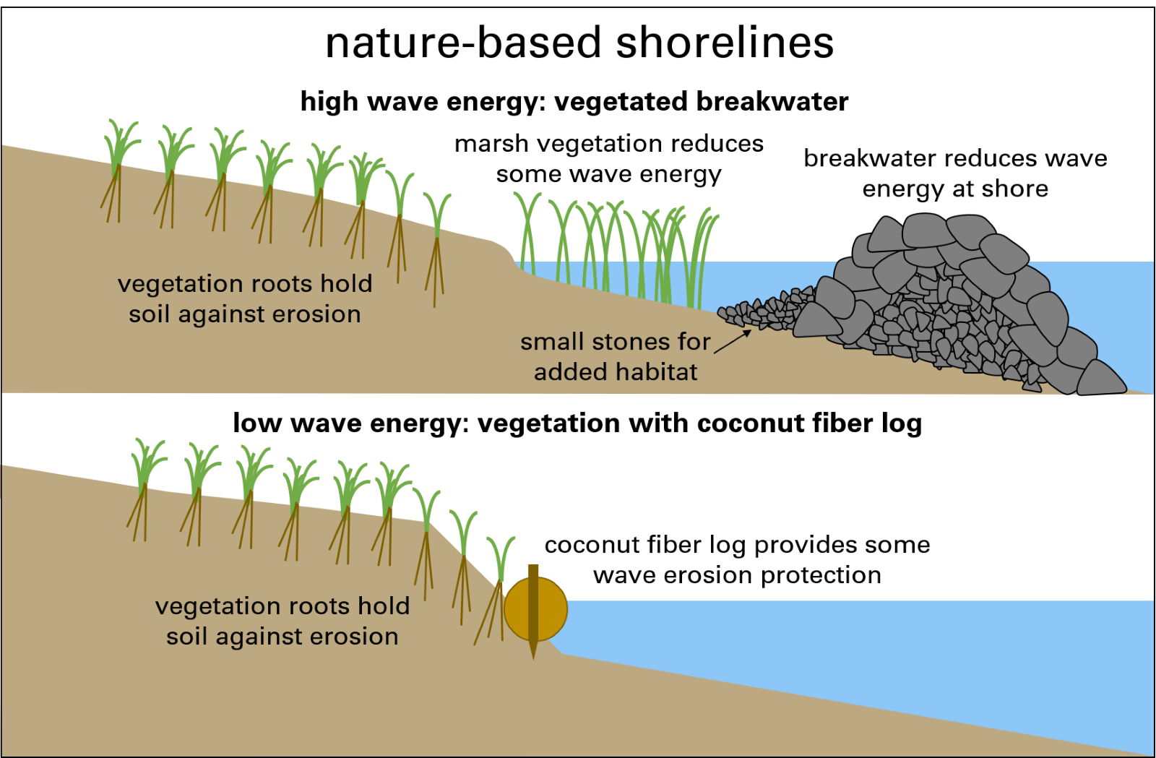

LESSON SIX: COASTAL ENGINEERING AT NORTH BEACH
Full Day Five Lesson Plan

LESSON CONCEPTS
- The sustainability of human societies and the biodiversity that supports them require responsible management of natural resources. Scientists and engineers can make major contributions — for example, by developing technologies that produce less pollution and waste and that preclude ecosystem degradation.

BACKGROUND INFORMATION FOR EDUCATOR
Background Information No additional information needed for this lesson.

LEARNING OBJECTIVES
Students can
- Perform calculations related to the amount of water generated from parking lot runoff and the size of a rain garden needed to manage this water.
- Differentiate gray infrastructure from green infrastructure.
- Describe a green infrastructure project at North Beach that manages water quality, quantity, or water movement, specifying what problem the project addresses and the design considerations.
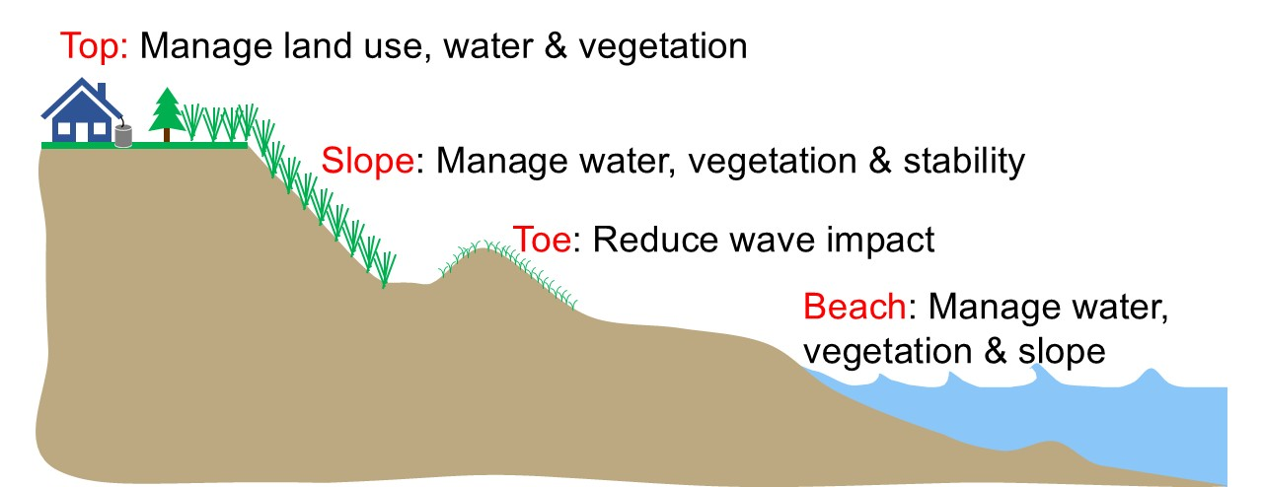

FILES NEEDED BY LESSON
Blue number at end of listing links to online document

LESSON ONE
- Detailed Version of Lesson 1
- Educator Background Information Introduction to Coastal Engineering 1
- Video What Is Engineering? 2
- Slideshow The Engineering Design Process 3
- Student Handout The Engineering Design Process for a Floatable Object 4
- Slideshow Racine Harbor Through Time 5
- Student Handout My Map of the City of Racine 6
- Slideshow Return to Racine Harbor 7
- Assessment Science vs. Engineering: Similarities and Differences 8
- Assessment Answer Key Science vs. Engineering --Answer Key 9
- Assessment Lesson 1 Exit Slip 10
- Educator Feedback Form 11

LESSON TWO
- Detailed Version of Lesson 2
- Educator Background Information The Coastal Features and Processes of the Great Lakes -- Background 12
- Background Slideshow Coastal Processes Demonstration -- The Wave Tank 13
- PowerPoint for Assessment Lake Michigan Water Levels 14
- Student Handout Lake Michigan Water Levels 15
- Assessment Answer Key Water Levels Answer Key 16
- Educator Background Slideshow Coastal Processes Demonstration --
The Wave Tank 17
- Student Handout Water and Sediment on the Lake Michigan Shoreline 18
- Student Assessment Coastal Terms Drag and Drop 19
- Assessment Answer Key Coastal Terms Answer Key 20
- Slideshow Four Coastal Processes 21
- Student Handout Historic Beach Width Measurement 22
- Educator Feedback Form 23

LESSON THREE
- Detailed Version of Lesson 3
- Educator Background Information Coastal Engineering Structures – Protecting the Shoreline - Background 24
- Educator Background Slideshow Wave Tank Demonstration 25
- Educator Background Support Materials Aerial Photographs 26
- Student Handout Using the EDP to Design a Coastal Structure 27
(includes: Slideshow Four Coastal Engineering Structures Found at North Beach) 28
- Student Handout Map it on Google Earth 29
- Assessment Answer Key Coastal Engineering Structures Answer Key 30
- Data spreadsheet Distances to North Beach 31
- Assessment Lesson Three Exit Slip 32
- Educator Feedback Form 33

LESSON FOUR
- Detailed Version of Lesson 4
- Educator Background Information Stormwater Management - Background 34
- Slideshow The Hydrologic Cycle 35
- Educator Activity Instructions Soil Infiltration and Percolation Test 36
- Student Handout Soil Infiltration & Percolation Test - Data Collection Sheet 37
- Slideshow Flooding at North Beach 38
- Slideshow Our Racine Today 39
- Assessment Lesson 4 Exit Slip 40
- Educator Feedback Form 41

LESSON FIVE
- Detailed Version of Lesson 5
- Educator Background Information Introduction to Green Infrastructure - Background 42
- Slideshow Racine Water Trivia 43
- Student Handout Calculating Runoff Amounts off a Roof 44
- Assessment Answer Key Calculating Runoff Amounts off a Roof Answer Key 45
- Video How Wetlands Manage Water 46
- Slideshow The Hydrologic Cycle 47
- Slideshow Green Infrastructure 48
- Student Handout Calculating Rain Garden Size 49
- Assessment Answer Key Calculating Rain Garden Size Answer Key 50
- Assessment Lesson 5 Exit Slip 51
- Educator Feedback Form 52

LESSON SIX
- Detailed Version of Lesson 6
- Educator Background Information No additional information needed.
- Student Handout Public Service Announcement for North Beach 53
- Slideshow Coastal Engineering at North Beach - Part 1 54
- Slideshow Coastal Engineering at North Beach - Part 2 55
- Handout Graphic Organizer 56
- Assessment Answer Key Graphic Organizer Answer Key 57
- Student Handout Calculating Runoff for Kids Cove Parking Lot 58
- Assessment Answer Key Calculating Runoff for Kids Cove Parking Lot Answer Key 59
- Student Handout Calculating Rain Garden Size for Kids Cove Parking Lot 60
- Assessment Answer Key Calculating Rain Garden Size for Kids Cove Parking Lot Answer Key 61
- Slideshow Green Infrastructure at North Beach 62
- Racine Beaches Quest Link 63
- Assessment Lesson Six Exit Slip 64
- Educator Feedback Form 65

STANDARDS

NEXT GENERATION SCIENCE STANDARDS
MS-ESS2-1 Earth's Systems
Develop a model to describe the cycling of Earth's materials and the flow of energy that drives this process. (Lesson 3, Lesson 4)

MS-ESS2-2 Earth's Systems
Construct an explanation based on evidence for how geoscience processes have changed Earth's surface at varying time and spatial scales. (Lesson 3)
MS-ESS3-2 Earth and Human Activity
Analyze and interpret data on natural hazards to forecast future catastrophic events and inform the development of technologies to mitigate their effects. (Lesson 2, Lesson 3, Lesson 5, Lesson 6)
MS-ESS2-4 Earth's Systems
Develop a model to describe the cycling of water through Earth's systems driven by energy from the sun and the force of gravity. (Lesson 4)
MS-ETS1-1 Engineering Design
Define the criteria and constraints of a design problem with sufficient precision to ensure a successful solution, taking into account relevant scientific principles and potential impacts on people and the natural environment that may limit possible solutions. (Lesson 1)
MS-ETS1-2 Engineering Design
Evaluate competing design solutions using a systematic process to determine how well they meet the criteria and constraints of the problem. (Lesson 1)
MS-ETS1-3 Engineering Design
Analyze data from tests to determine similarities and differences among several design solutions to identify the best characteristics of each that can be combined into a new solution to better meet the criteria for success. (Lesson 1)
MS-ETS1-4 Engineering Design
Develop a model to generate data for iterative testing and modification of a proposed object, tool, or process such that an optimal design can be achieved. (Lesson 1)

NEXT GENERATION CROSS CUTTING PRINCIPALS
3. Scale, proportion, and quantity. In considering phenomena, it is critical to recognize what is relevant at different measures of size, time, and energy and to recognize how change in scale, proportion, or quantity affect a system’s structure or performance. (Lesson 1, Lesson 2, Lesson 3, Lesson 4, Lesson 5, Lesson 6)
6. Structure and function. The way in which an object or living thing is shaped and its substructure determine many of its properties and functions. (Lesson 1, Lesson 2, Lesson 3, Lesson, 4, Lesson 5, Lesson 6)

WISCONSIN MODEL ACADEMIC STANDARDS FOR ENVIRONMENTAL LITERACY & SUSTAINABILITY
ELS.C1.B.m Sense of Place Identify the relationship between parts of natural and cultural systems in connecting communities into regional systems (e.g., watershed areas, political jurisdictions, ethnic communities). Understand the relationships between the environment and geography of a locality and its history, culture, and economy. (Lesson 1)
ELS.C1.C.m Curiosity and Wonder Ask questions about patterns and cause and effect relationships in natural and cultural systems observed outdoors daily, seasonally, and over time. Examine how curiosity and wonder help formulate questions to pursue knowledge about everyday experiences. (Lesson 2)
ELS.EX2.A.m Systems Thinking Create a model of a system, identify hidden relationships and perspectives, and analyze nested systems of its parts and wholes. Reorganize a system through analyzing alternative boundaries, perspectives, and relationships. Compare the relationship between two wholes by comparing the relationships of the parts. (Lesson 4)
ELS.EX3.B.m Explore Natural Systems Emphasis Analyze how new knowledge or technological solutions impact natural resource use, or improve environmental quality. (Lesson 3, Lesson 5, Lesson 6)
ELS.EX5.C.m Examine Cultural System Emphasis Examine how historical and contemporary factors shape a sustainability issue. Evaluate how historical and contemporary natural resource use, practices, and distribution has [sic] affected human geography and analyze the impact on natural systems. (Lesson 1)

WISCONSIN MODEL ACADEMIC STANDARDS FOR MATHEMATICS
M.6.RP.A.3 d. Understand Ratio Concepts Use ratio reasoning to convert measurement units; manipulate and transform units appropriately when multiplying or dividing quantities. (Lesson 5, Lesson 6)
M.6.SP.B.5 Summarize and Describe Distributions Describe the nature of the attribute under investigation, including how it was measured and its units of measurement. (Lesson 3)
M.7.G.A.1 Draw, construct, and describe geometrical figures and describe the relationships between them Solve problems involving scale drawings of geometric figures, including computing actual lengths and areas from a scale drawing and reproducing a scale drawing at a different scale. (Lesson 1)
M.8.EE.A.4 Work with Radical and Integer Exponents Choose units of appropriate size for measurements of very large or very small quantities. (Lesson 5, Lesson 6)
M.8.F.B.5 Use Functions to Model Relationships Between Quantities. Describe qualitatively the functional relationship between two quantities by analyzing a graph (e.g., where the function is increasing or decreasing, linear or nonlinear, continuous or discrete). (Lesson 2)

WISCONSIN MODEL ACADEMIC STANDARDS FOR SCIENCE
MS-ESS2-2 Construct an explanation based on evidence for how geoscience processes have changed Earth's surface at varying time and spatial scales. (Lesson 2, Lesson 3, Lesson 4)
MS-ESS3-2 Analyze and interpret data on natural hazards to forecast future catastrophic events and inform the development of technologies to mitigate their effects. (Lesson 3)
MS-ESS3-3 Apply scientific principles to design a method for monitoring and minimizing a human impact on the environment. (Lesson 5, Lesson 6)
MS-ETS1-2 Engineering Design Evaluate competing design solutions using a systematic process to determine how well they meet the criteria and constraints of the problem. (Lesson 1)
SCI.ESS2.A.4 Earth Materials and Systems Rainfall helps to shape the land and affects the types of living things found in a region. Water, ice, wind, organisms, and gravity break rocks, soils, and sediments into smaller pieces and move them around. (Lesson 4)
SCI.ESS2.C.m The Role of Water in Earth’s Surface Processes Water cycles among land, ocean, and atmosphere, and is propelled by sunlight and gravity. Water movement causes weathering and erosion, changing landscape features. (Lesson 2, Lesson 3, Lesson 4, Lesson 5, Lesson 6)
SCI.ESS3.B.m Natural Hazards Patterns can be seen through mapping the history of natural hazards in a region and understanding related geological forces. (Lesson 2, Lesson 3)
SCI.ESS3.C.m Human Impacts on Earth’s Systems Human activities have altered the hydrosphere, atmosphere, and lithosphere which in turn has altered the biosphere. Activities and technologies can be engineered to reduce people’s impacts on Earth. (Lesson 2, Lesson 3, Lesson 4, Lesson 5, Lesson 6)
SCI.ETS1.B.m Developing Possible Solutions A solution needs to be tested and then modified on the basis of the test results in order to improve it. There are systematic processes for evaluating solutions with respect to how well they meet the criteria and constraints of a problem. (Lesson 1)
SCI.ETS1.C.m Optimizing the Design Solution Although one design may not perform the best across all tests, identifying the characteristics of the design that performed the best in each test can provide useful information for the redesign process. The iterative process of testing the most promising solutions and modifying what is proposed on the basis of the test results leads to greater refinement and ultimately to an optimal solution. (Lesson 1)

SCI.ETS2.B.m Influence of Engineering, Technology, and Science on Society and the Natural World All human activity draws on natural resources and has both short- and long-term consequences, positive as well as negative, for the health of people and the natural environment. The uses of technologies are driven by people’s needs, desires, and values; by the findings of scientific research; and by differences in such factors as climate, natural resources, and economic conditions. Technology use varies over time and from region to region. (Lesson 3, Lesson 4, Lesson 5, Lesson 6)
SCI.ETS3.B.m Science and Engineering are Unique Ways of Thinking with Different Purposes Science asks questions to understand the natural world and assumes that objects and events in natural systems occur in consistent patterns that are understandable through measurement and observation. Science carefully considers and evaluates anomalies in data and evidence. Engineering seeks solutions to human problems, including issues that arise due to human interaction with the environment. It uses some of the same practices as science and often applies scientific principles to solutions. (Lesson 1)
SCI.ETS3.C.m Science and Engineering Use Multiple Approaches to Create New Knowledge and Solve Problems Engineers develop solutions using multiple approaches and evaluate their solutions against criteria such as cost, safety, time, and performance. This evaluation often involves trade-offs between constraints to find the optimal solution. (Lesson 1)
SCI.SEP1.A.m Asking Questions Ask questions to clarify or refine a model, an explanation, or an engineering problem. (Lesson 1)
SCI.SEP2.m Developing and Using Models Students develop, use, and revise models to describe, test, and predict more abstract phenomena and design systems. (Lesson 4)
SCI.SEP4.m Defining a Problem Analyze data to define an optimal operational range for a proposed object, tool, process, or system that best meets criteria for success. (Lesson 1)
SCI.SEP6.B.m Designing Solutions Apply scientific ideas or principles to design, construct, and test a design of an object, tool, process, or system. Undertake a design project, engaging in the design cycle, to construct and implement a solution that meets specific design criteria and constraints. Optimize performance of a design by prioritizing criteria, making trade-offs, testing, revising, and retesting. (Lesson 1)

WISCONSIN MODEL ACADEMIC STANDARDS FOR SOCIAL STUDIES
SS.BH4.a.m Progression of Technology Differentiate between intended and unintended consequences of various forms of technology and how they may affect societies and cultures. (Lesson 2, Lesson 3)
SS.Econ1.a.m Choices and Decision Making Predict the opportunity costs of various decisions and explain why the opportunity cost might differ from person to person or in different situations. Assess how limited resources (e.g., money, land, natural resources, workers, time) impact the choices of individuals, households, communities, businesses, and countries. (Lesson 3)

SS.Geog1.a.m Tools of Geography Use paper and digital maps to ask and answer geographic questions. (Lesson 1, Lesson 3)
SS.Geog 1.c.m Mental Mapping and Maps from Memory Construct a mental map of regions. (Lesson 1)
SS.Geog5.a.m Human Environment Interaction Analyze how technology interacts with the environment and how increased use of technology affects the burden and use of natural resources. (Lesson 3, Lesson 5, Lesson 6)

WISCONSIN MODEL ACADEMIC STANDARDS FOR LANGUAGE ARTS
W.7.2.b Write text in a variety of modes. Write informative text that examines a topic and conveys ideas, concepts, and information through the selection and organization of relevant content by introducing and developing a topic with relevant, well-chosen facts, definitions, concrete details, quotations, or other information and examples, organizing ideas, concepts, and information into broader categories; include formatting (e.g., headings), graphics (e.g., charts, tables), and multimedia when useful to aiding comprehension. (Lesson 5, Lesson 6)

WISCONSIN MODEL ACADEMIC CORE IDEAS
ESS2.C: The Role of Water in Earth's Surface Processes (Lesson 1, Lesson 2, Lesson 4)
ESS3.B: Natural Hazards (Lesson 1, Lesson 2)
ESS3.C: Human Impacts on Earth Systems (Lesson 1, Lesson 2, Lesson 5, Lesson 6)

GREAT LAKES LITERACY PRINCIPLES
- Principle 1: The Great Lakes, bodies of fresh water with many features, are connected to each other and to the world ocean.
  - 1D: Rivers and streams transport nutrients, dissolved gases, salts and minerals, sediments and pollutants from watersheds into the Great Lakes (Lesson 4, Lesson 5, Lesson 6)
  - 1E: The Great Lakes are an integral part of the water cycle and are connected to the region’s watersheds and water systems. Changes in water systems affect the quality, quantity and movement of water, including retention time. (Lesson 2, Lesson 4, Lesson 5, Lesson 6)
  - 1F: Water currents circulate within the Great Lakes and are powered by wind, waves, energy from the sun and water density differences. The shape of a lakebed and its geographic orientation, the direction of the prevailing winds, the shores and the structures along the shores influence the path of circulation. Circulation between the lakes is driven by gravity. (Lesson 2)
  - 1G: Lake level is the height of the Great Lakes relative to sea level. Lake level changes are caused by variations in precipitation, evaporation, runoff, and snow melt, as well as wind and waves. While tides are typically not discernable in the Great Lakes, seiches are common in the Lakes. (Lesson 2)
- Principle 2: Natural forces formed the Great Lakes; the lakes continue to shape the features of their watershed.
  - 2D: Erosion – the wearing away of rock, soil and other earth materials – occurs in coastal areas as wind, waves, and currents in rivers and the Great Lakes move sediments. (Lesson 2, Lesson 3)

2E: Sediments are a product of erosion and consist of fragments of animals, plants, rocks and minerals. Sediments are classified by grain sizes, from silt and clay to sand, cobbles and boulders. Sediments are seasonally redistributed by waves and coastal currents and help maintain beaches and coastal wetlands. (Lesson 2, Lesson 3)
- Principle 6. The Great Lakes and humans in their watersheds are inextricably interconnected.
  - 6C: The Great Lakes are affected directly by the decisions and actions of people throughout its watershed which includes parts of the states of Illinois, Indiana, Michigan, Minnesota, Ohio, Pennsylvania, New York, and Wisconsin, the Canadian provinces of Ontario and Quebec, and tribal lands. (Lesson 1, Lesson 3, Lesson 4, Lesson 5, Lesson 6)
  - 6D: Local and national laws, regulations and resource management affect what is put into and taken out of the Great Lakes. Shoreline development and industrial or commercial activities lead to point and nonpoint source pollution. (Lesson 4, Lesson 5, Lesson 6)

6E: Coastal regions along the Great Lakes are impacted by land use decisions and natural hazards. Physical modifications (changes to beaches, shores, and rivers) can exacerbate effects of erosion, storm surges, and lake level changes. (Lesson 3, Lesson 4, Lesson 5, Lesson 6)

6F: To ensure continued availability of Great Lakes assets, people must live in ways that sustain the lakes. Individual and collective actions are needed to effectively conserve and manage Great Lakes resources for the benefit of all. (Lesson 4, Lesson 5, Lesson 6)

Principle 7: Much remains to be learned about the Great Lakes.

7B: Understanding the Great Lakes is more than a matter of curiosity. Exploration, inquiry and monitoring promote better understanding and protection of Great Lakes ecosystems, resources and processes. (Lesson 5, Lesson 6)
- Principle 8. The Great Lakes are socially, economically and environmentally significant to the region, the nation and the planet.
  - 8B. The waters of the Great Lakes have been significant to historical settlement and development. The lakes’ names and the names of many cities, counties and landmarks along their shores have Native American or immigrant origins. This freshwater resource will continue to play a role in future habitation of the area. (Lesson 1)

8F: The Great Lakes were dramatically degraded and challenged by human endeavors in recent times. Basic ecosystem processes have been restored through individual and collective efforts. Proper foresight and informed decision making will continue to make the Great Lakes a model of environmental protection, restoration and innovation. (Lesson 5, Lesson 6)
(Source: Ohio Sea Grant. (2013). Great Lakes Literacy: Essential Principles and Fundamental Concepts for Great Lakes Learning. OHSU-B-090. National Science Foundation, National Oceanic and Atmospheric Administration, Sea Grant Great Lakes Network, Centers for Ocean Sciences Education Excellence (COSEE))
Complete list of Great Lakes Literacy Principles available at: www.cgll.org

Website with all lesson plans and supporting materials
go.wisc.edu/coastal-engineering




